JENKINS INSTALLATION:

DOWNLOAD JENKINS:

Following steps should be followed so that to install Jenkins successfully:

Step 1) Go to <https://www.jenkins.io/download/> and select the platform. In our case Windows.

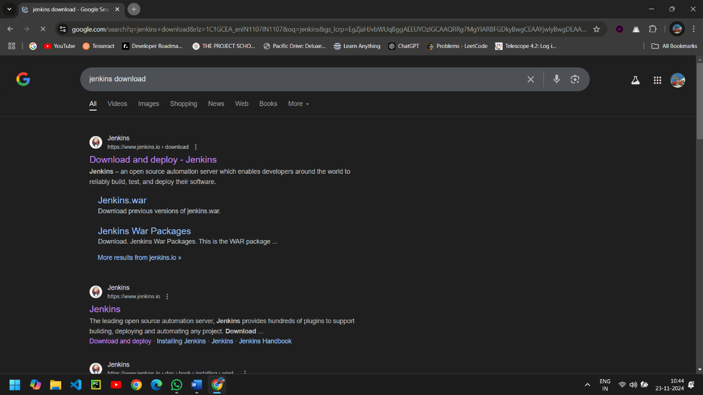

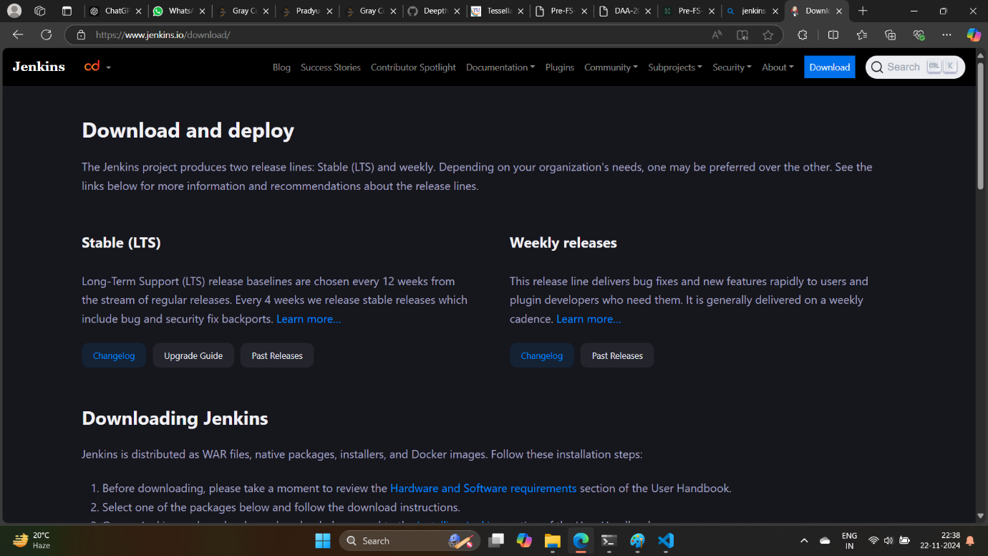

INSTALLATION OF JENKINS: 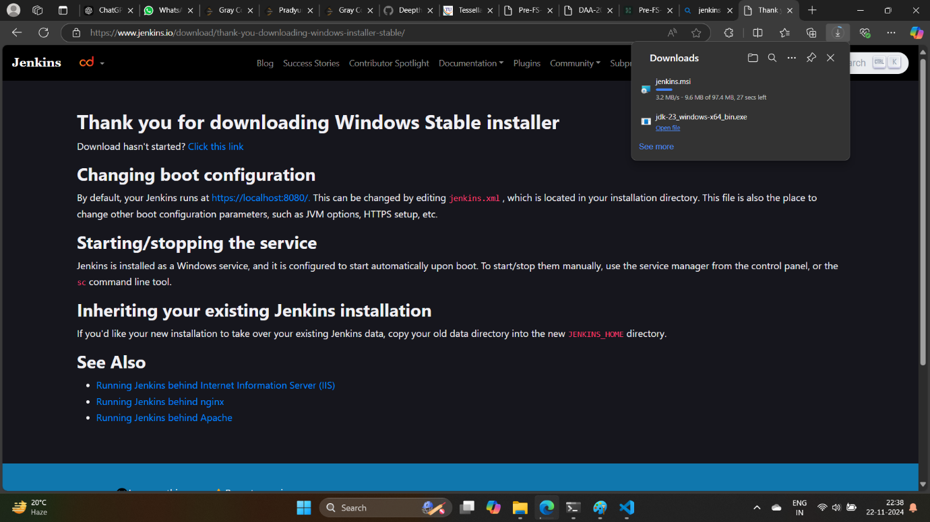

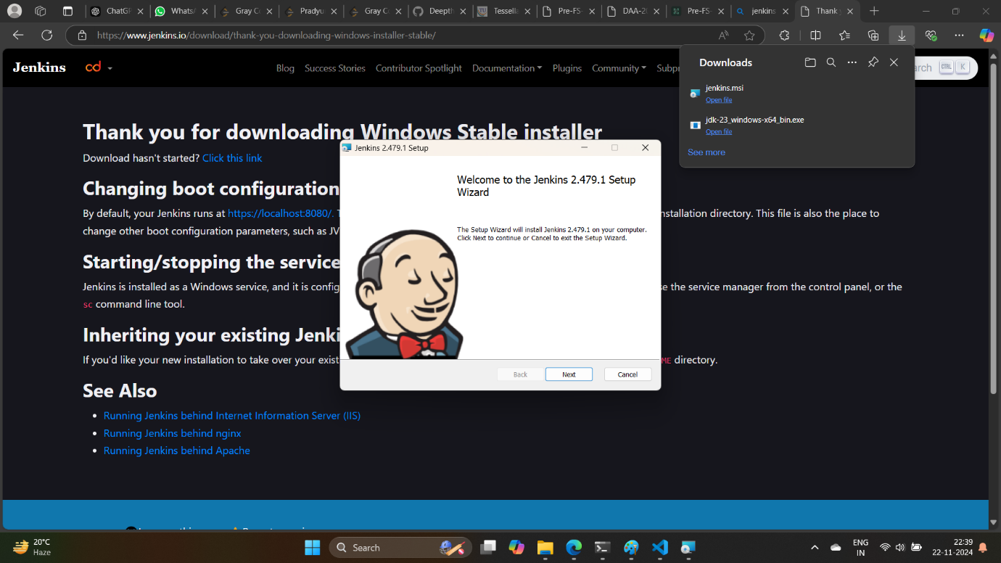

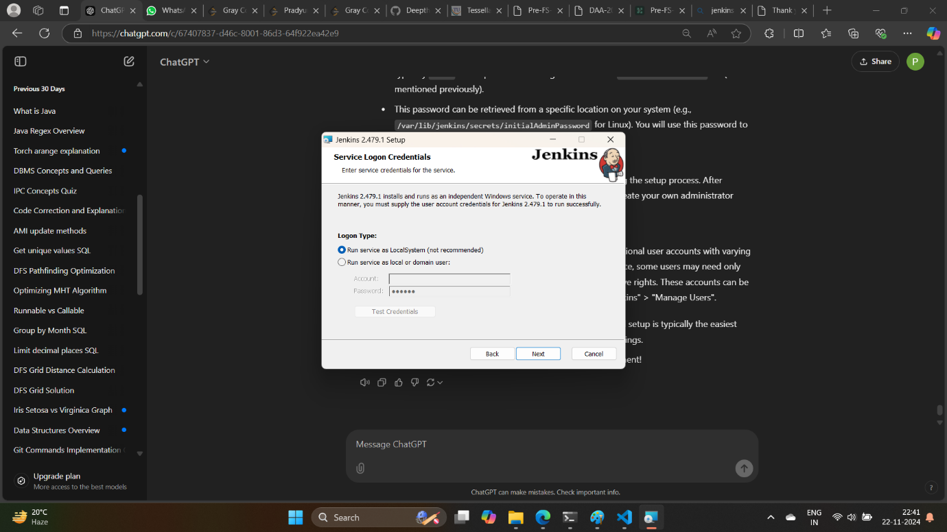

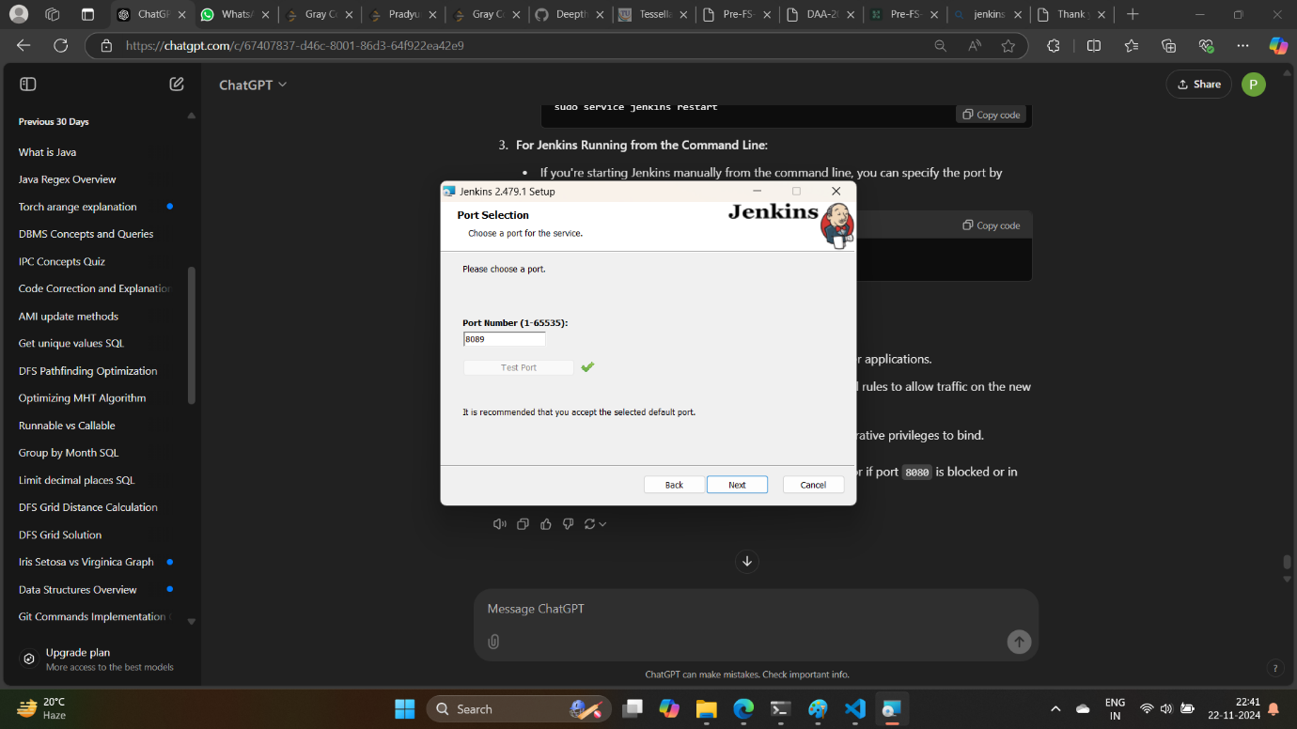

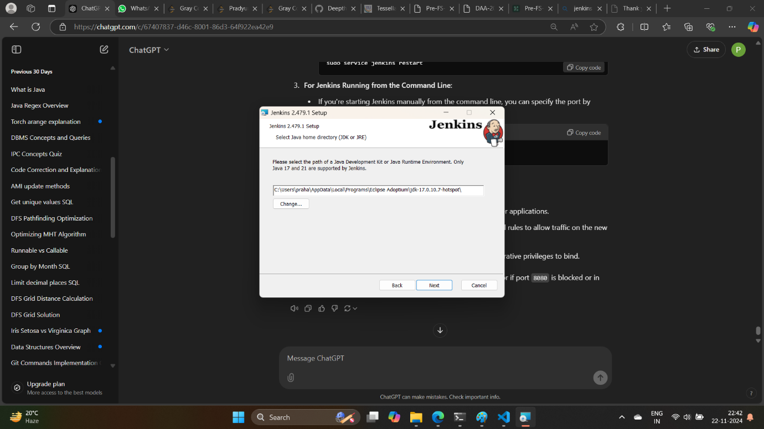

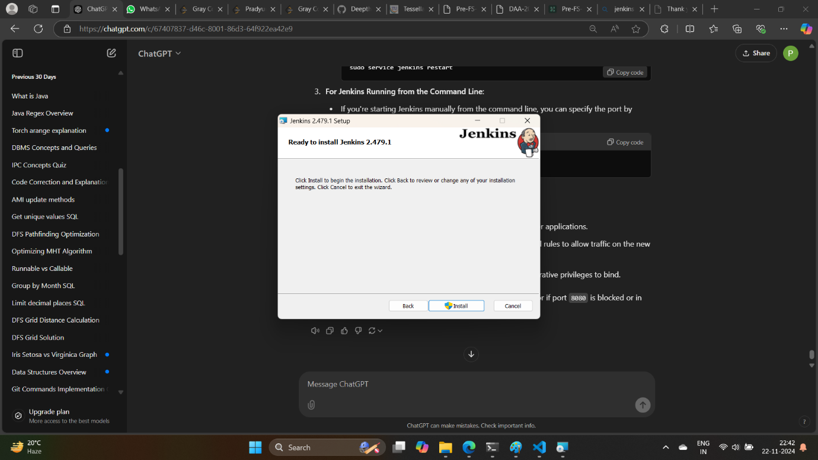

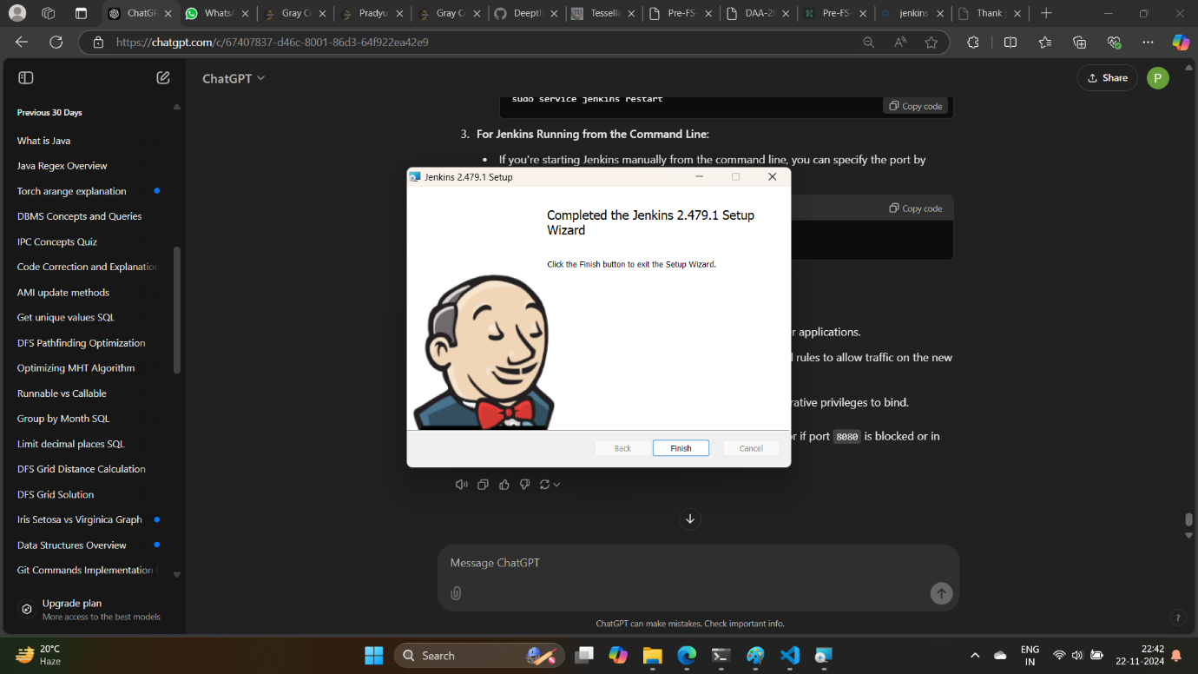

Launch local host 8069 on browser and follow the path shown.

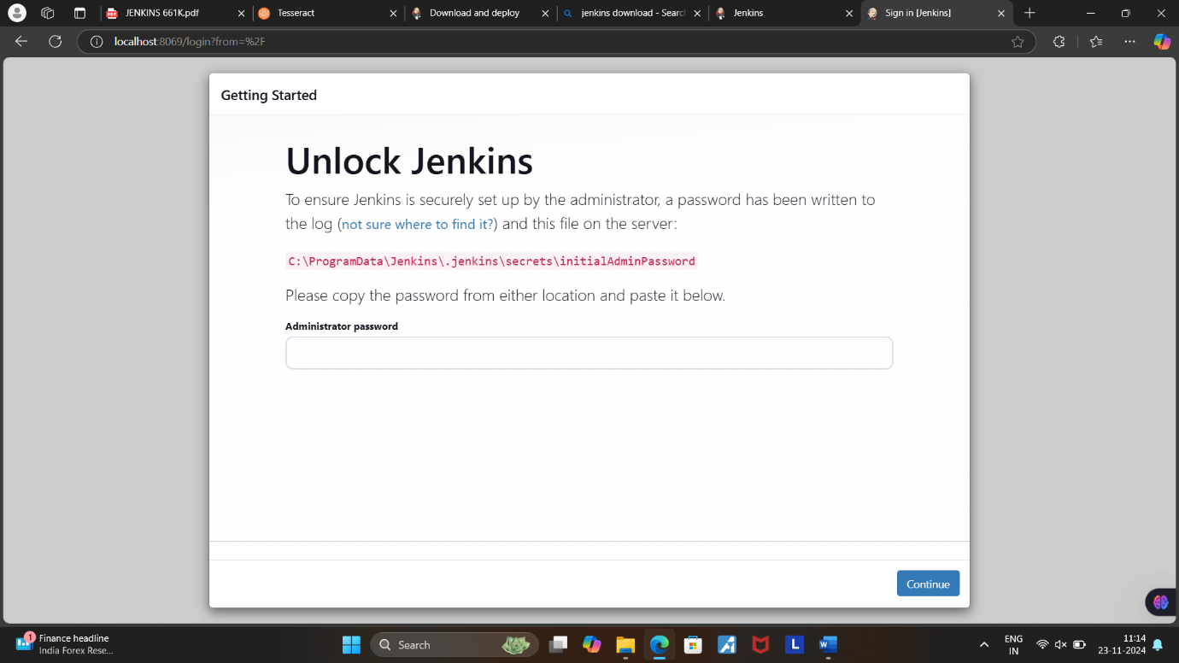

Copy the text from the provided path(file).

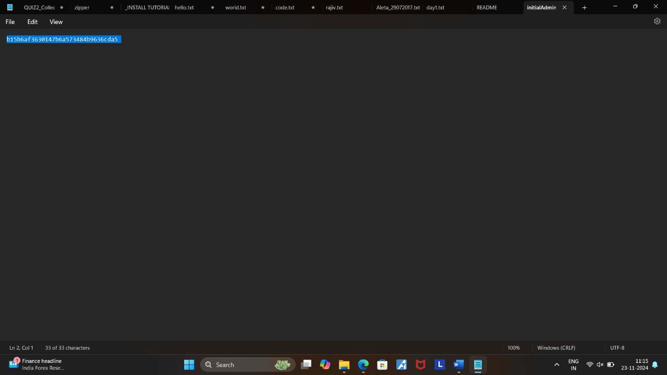

Paste it in the localhost Unlock Jenkins Page.(In Administrator Password Block)

Then click on continue.

INSTALLATION OF JENKINS PLUGINS:

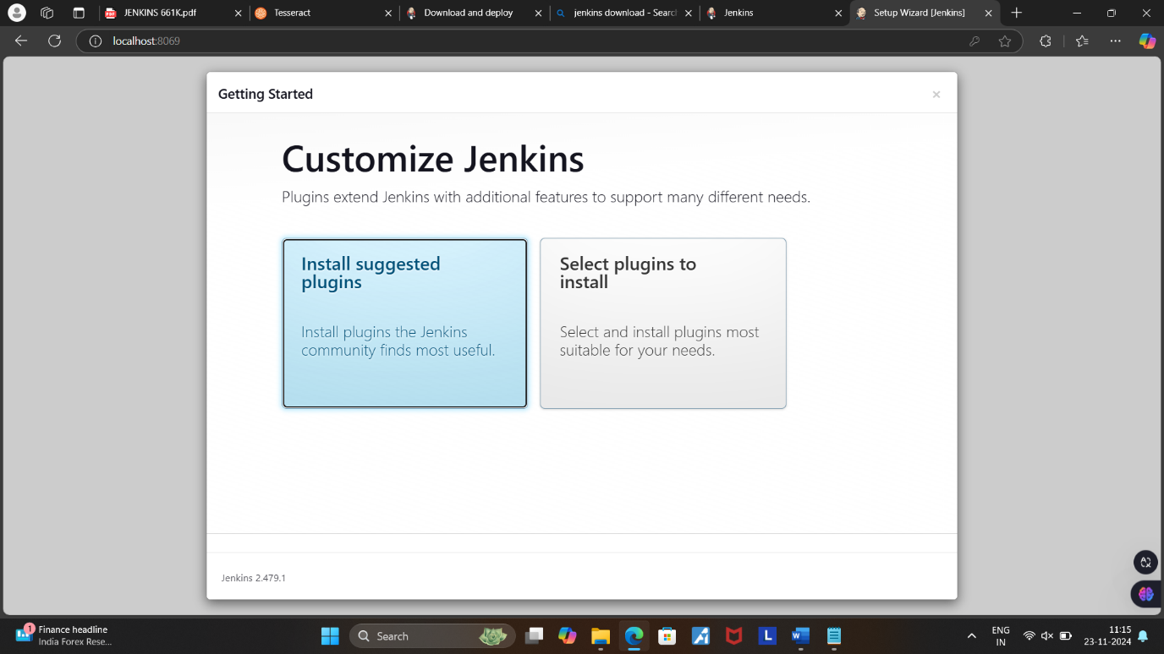

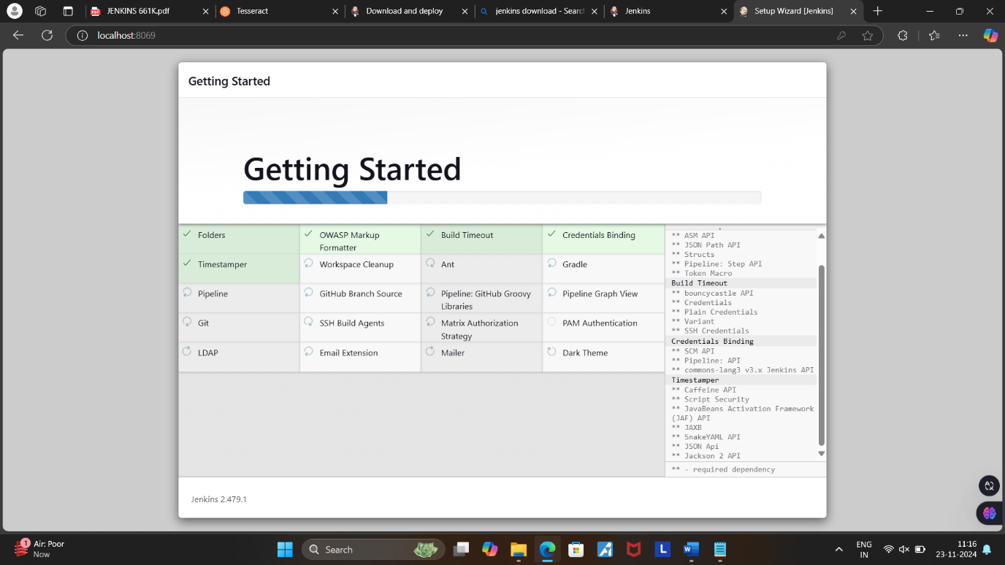

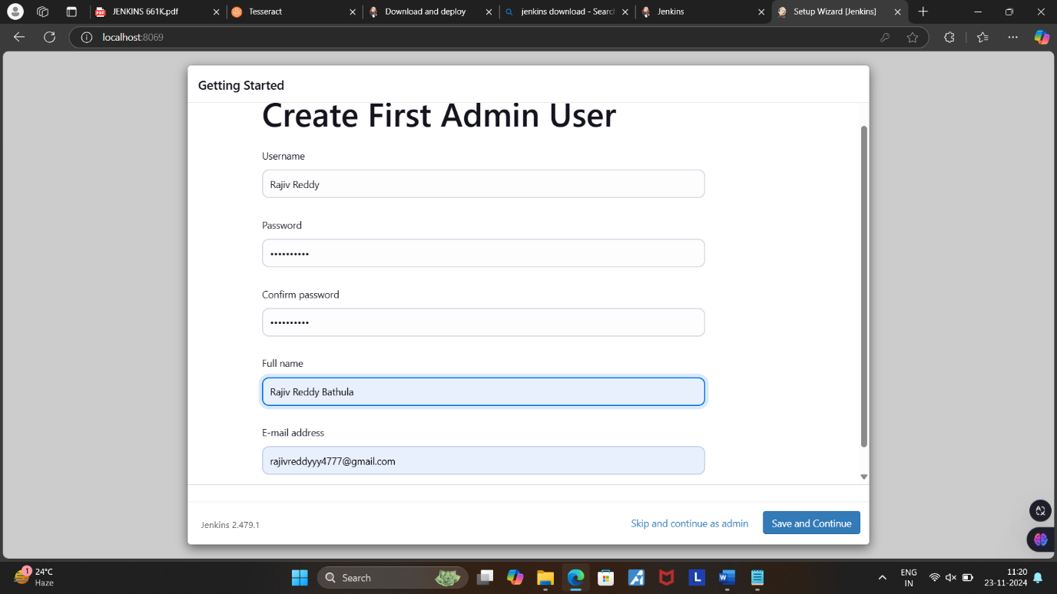

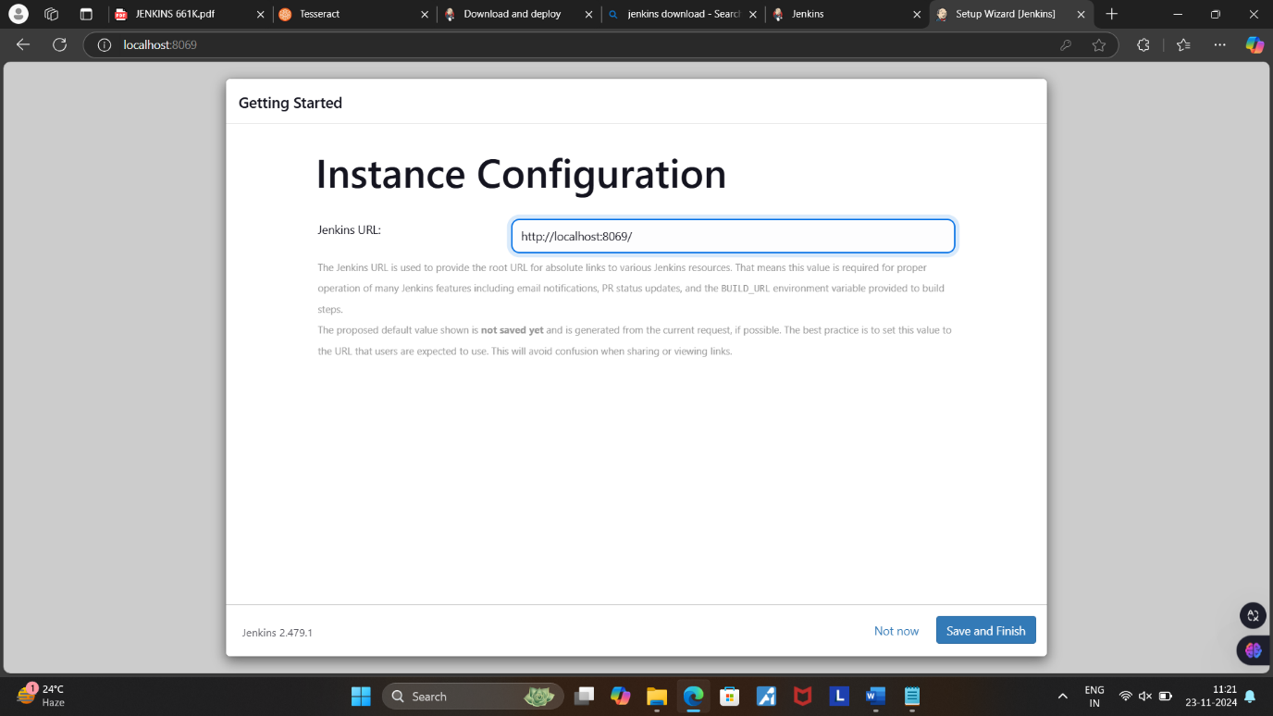

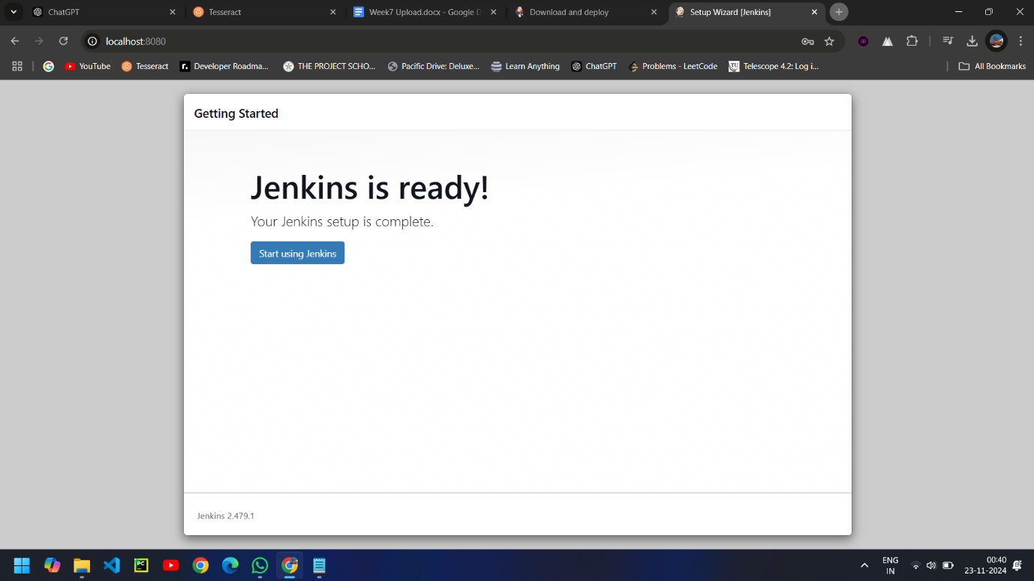

JENKINS DASHBOARD:

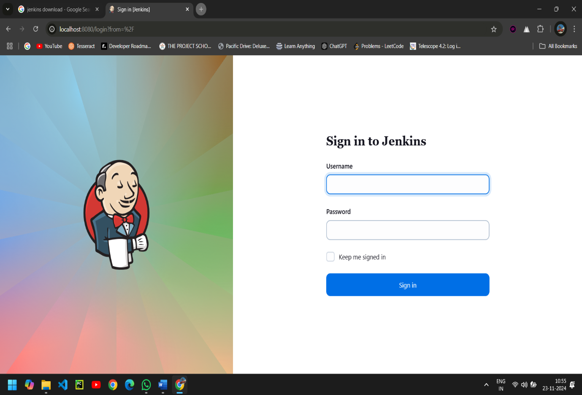

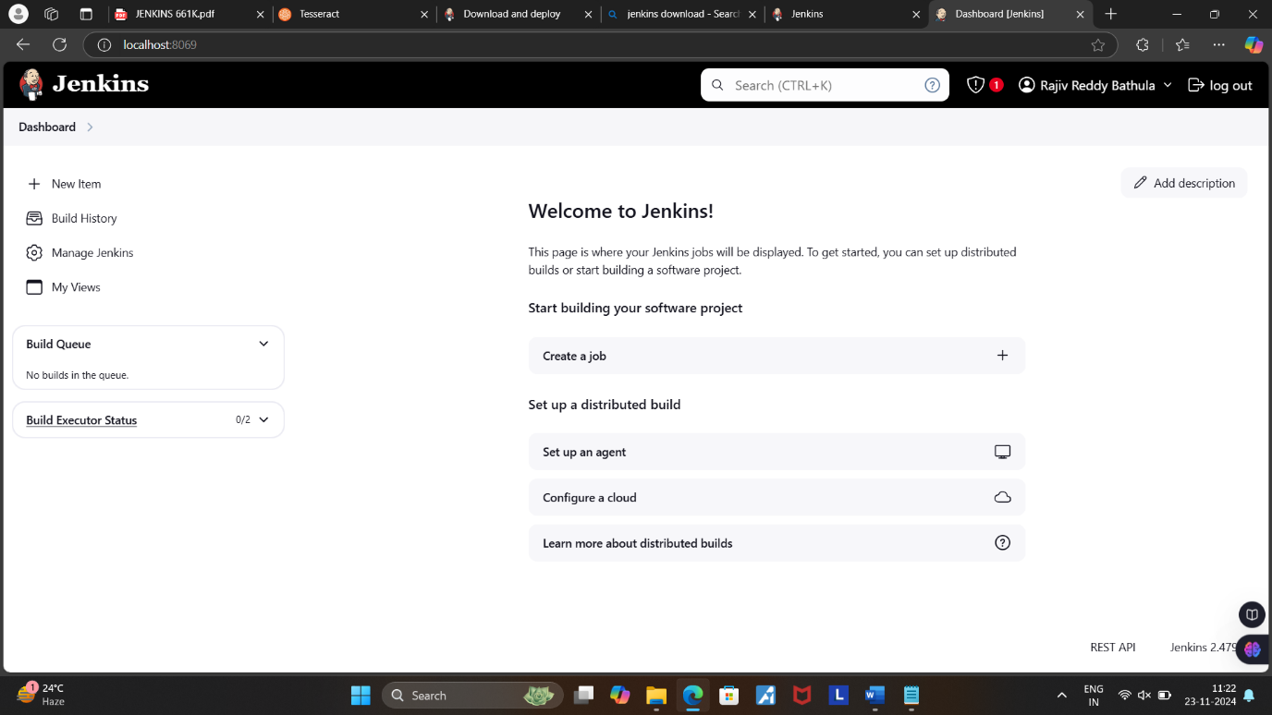

Click on manage Jenkins on the Dashboard.

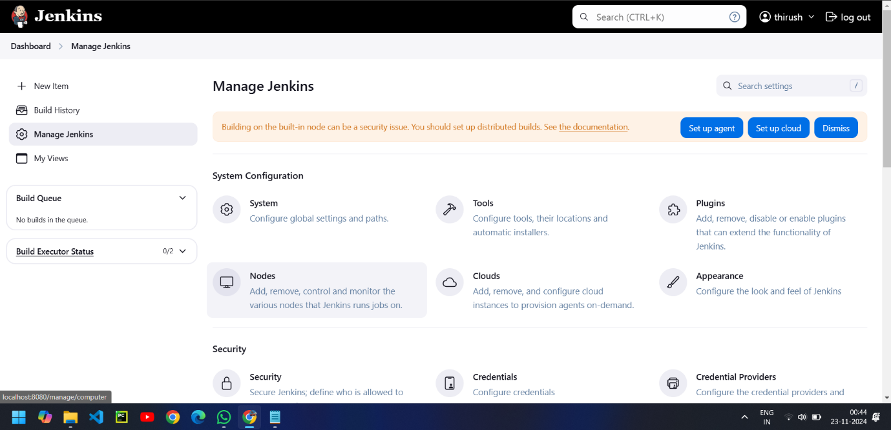

INSTALL PLUGINS IN JENKINS:

Check in the available and install the plugins  
Maven integration plugin,   
Build pipeline plugin,   
Pipeline utility,   
Copy artifacts,  
Deploy to container.  
click on -> install without restart.

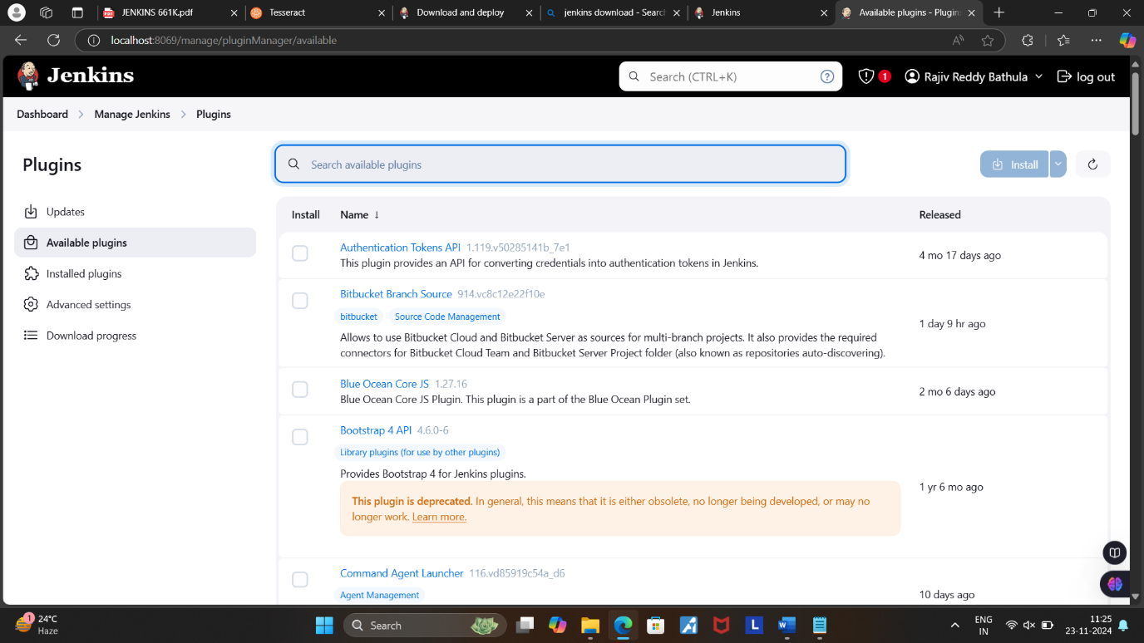

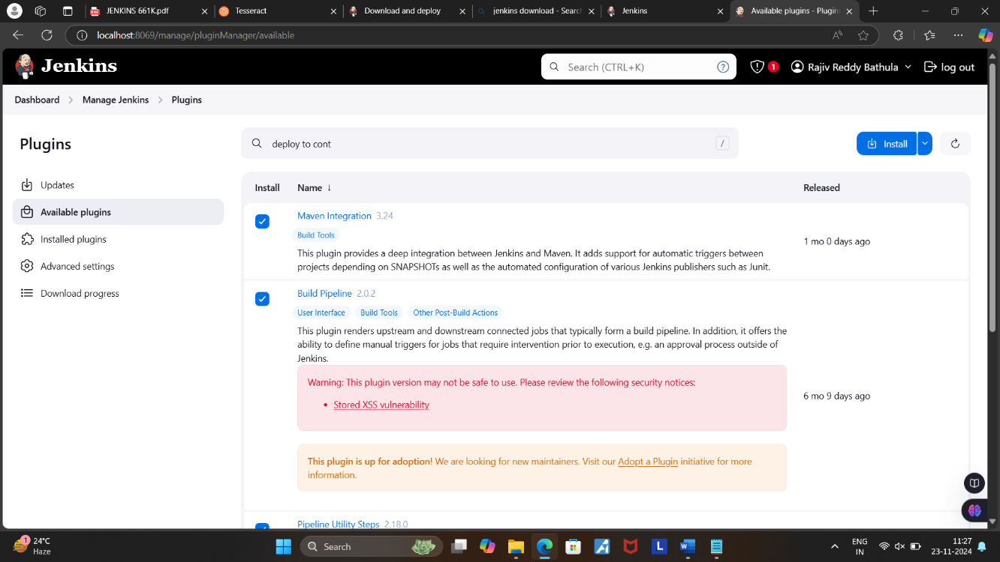

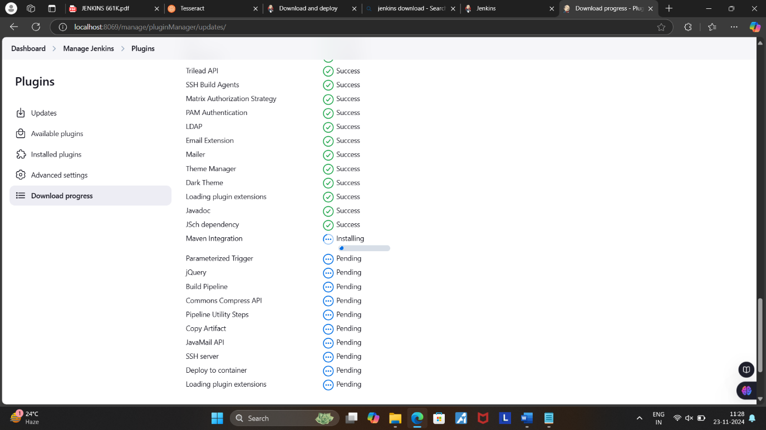

CONFIG YOUR JENKINS WITH MAVEN

Select Tools on Manage Jenkins Tab.

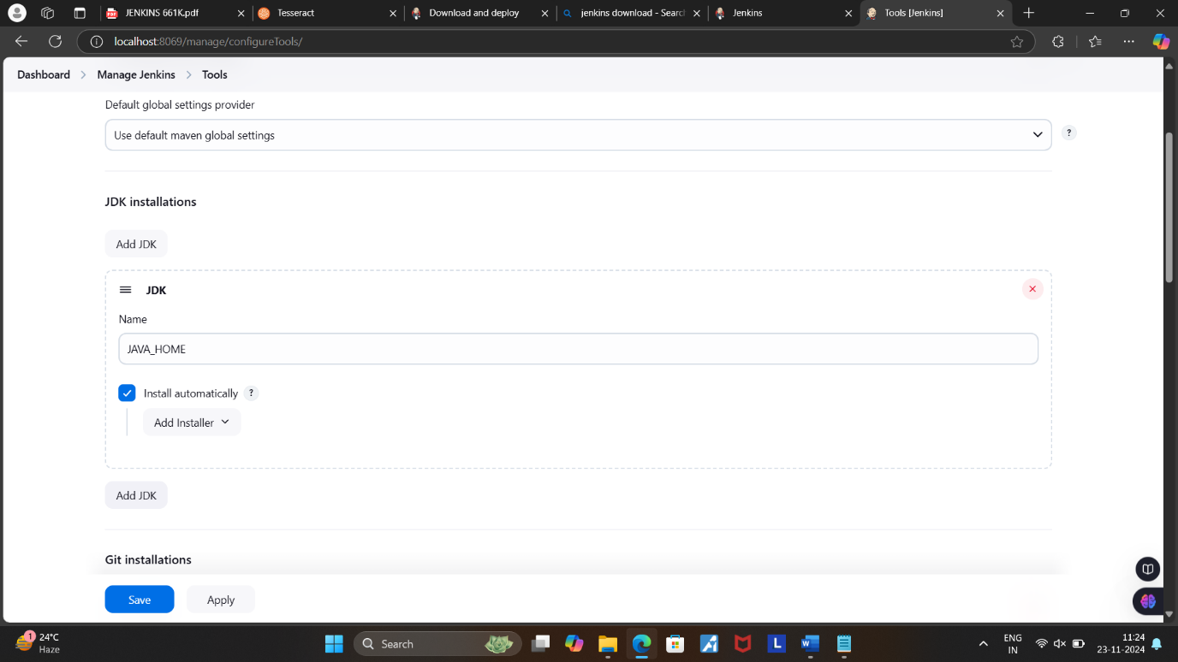

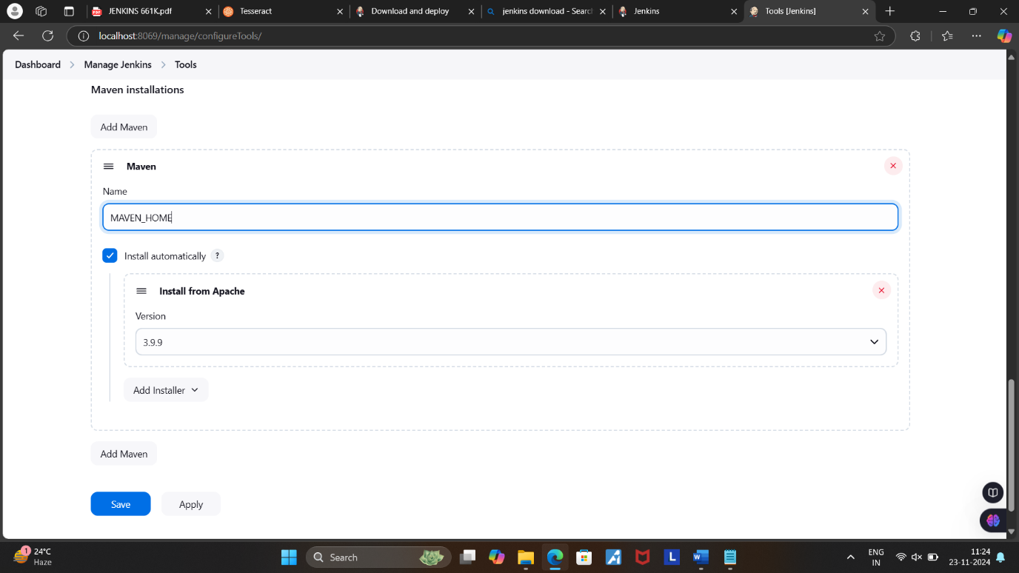

Now Click on Apply and Save.

**BUILDING THE FREESTYLE PIPELINE USING JENKINS FOR MAVEN JAVA PROJECT**

* Open Jenkins in local host:8069 and create a new item.

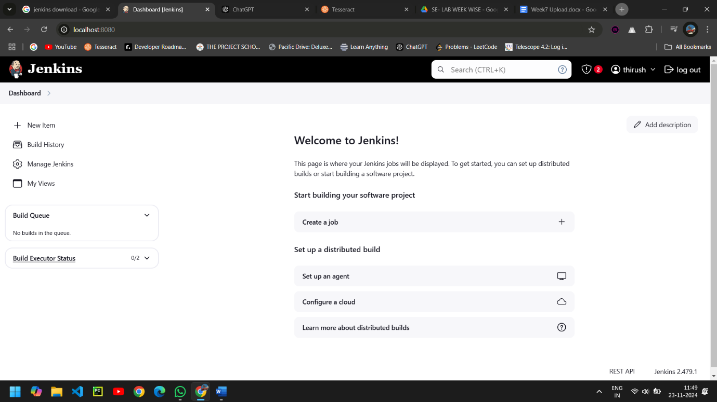

* Create a new Freestyle Project and click ok.

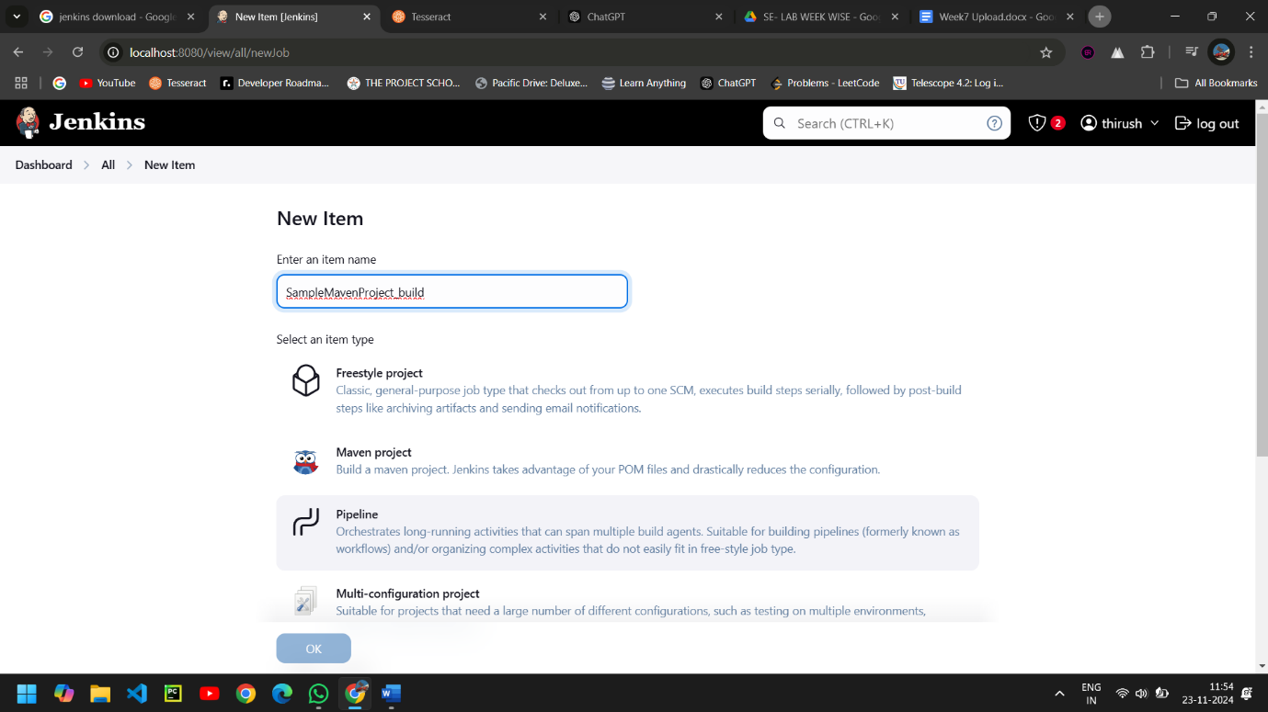

* Copy the Maven java Project Git Repository URL from GITHUB.

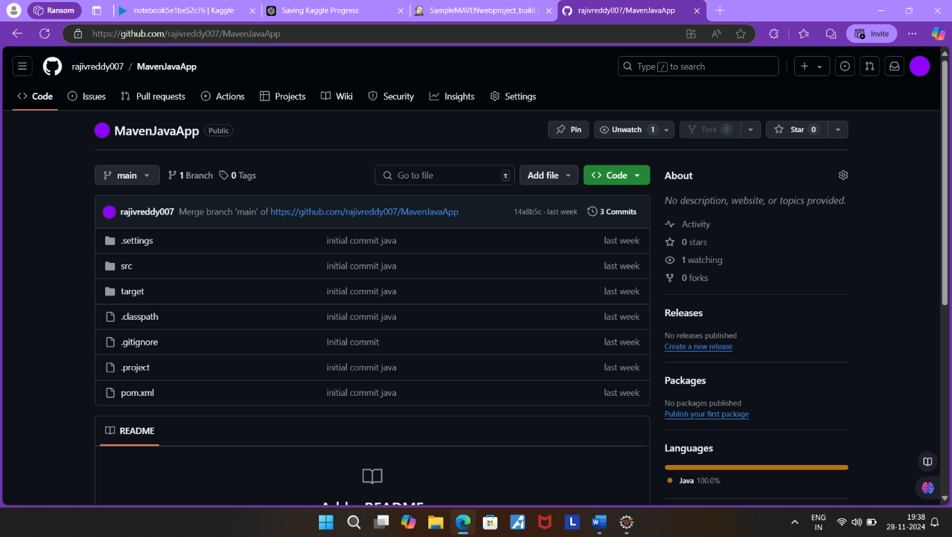

* Give the Git repository URL.

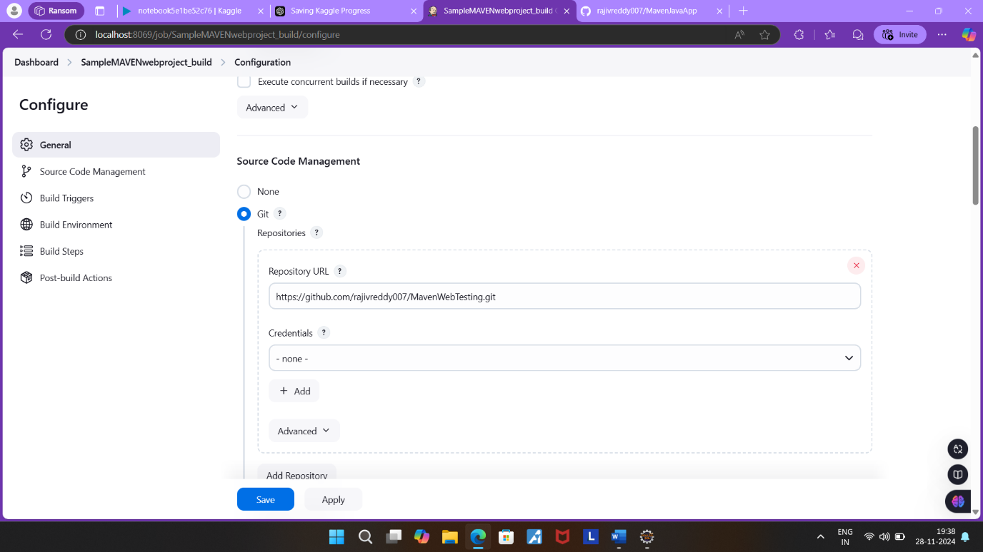

* After adding the repository URL, Specify the Branch as either Master/Main as it is in the GitHub.

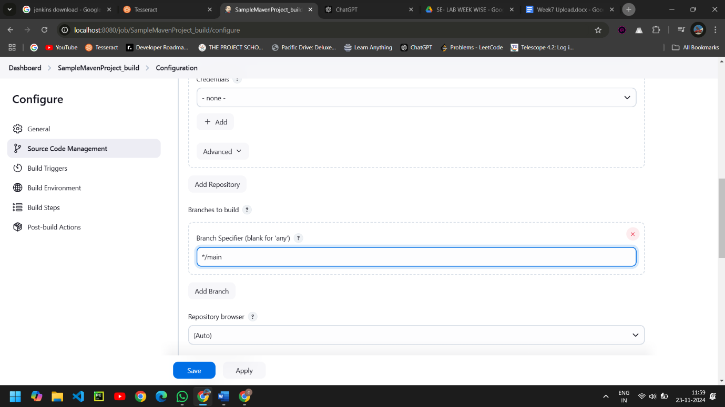

* Now in Build, select Invoke top-level Maven targets.

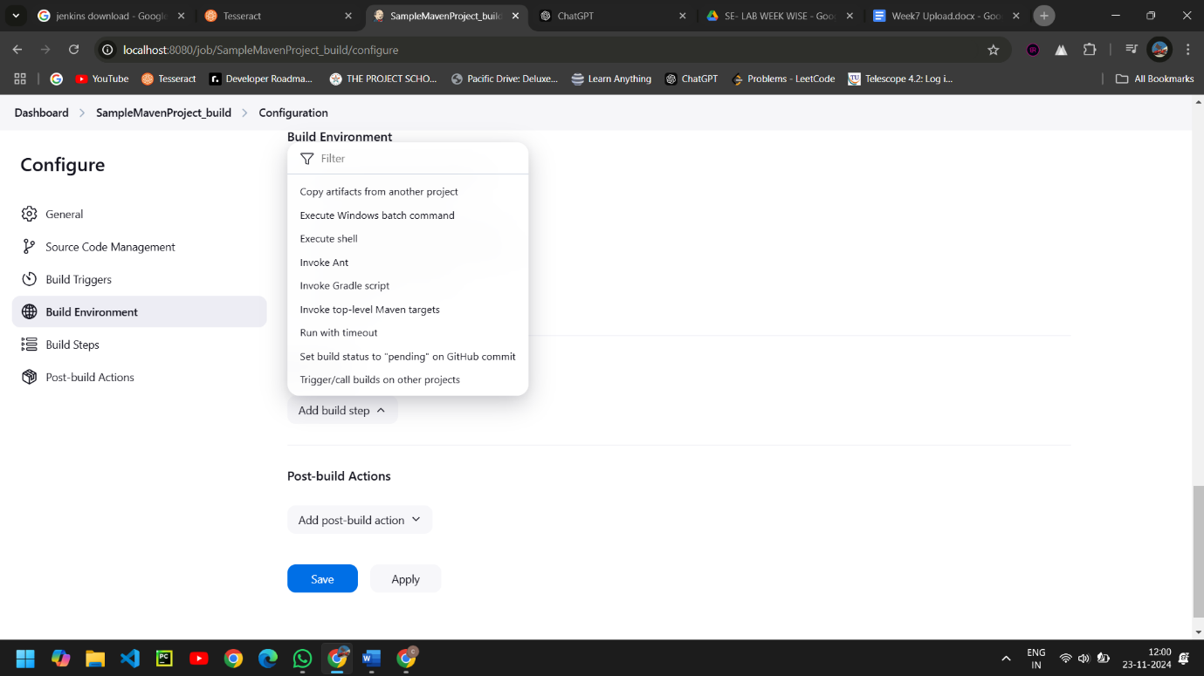

* Select the Maven path which is already set in the global credentials in Manage Jenkins, Follow the same goals as done in eclipse starting with clean and install.

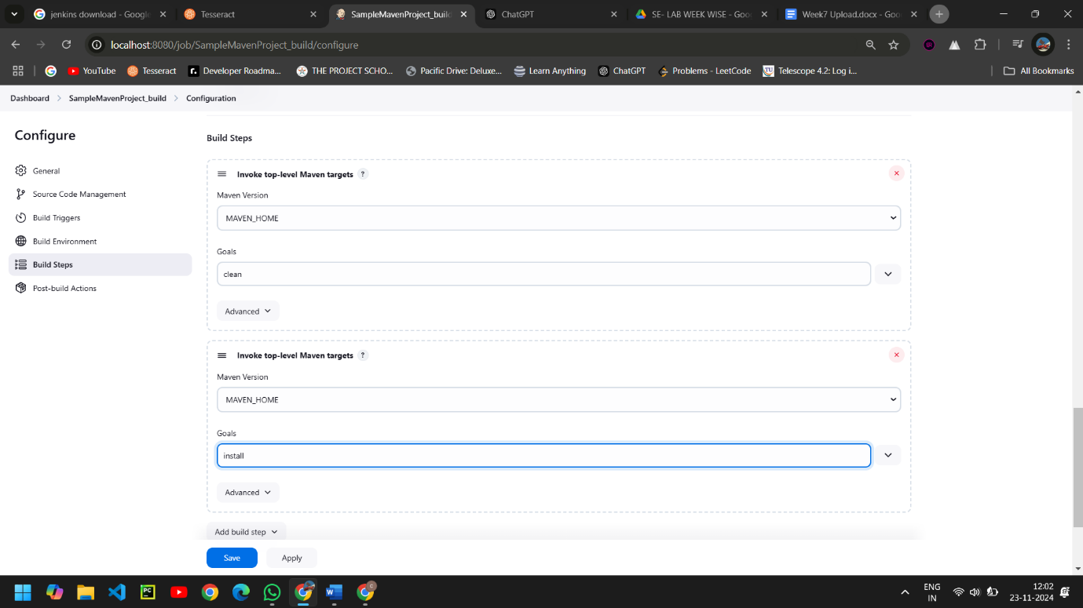

* Now in post build actions-> select Archive the artifacts, to send the output of build project to the testing team.

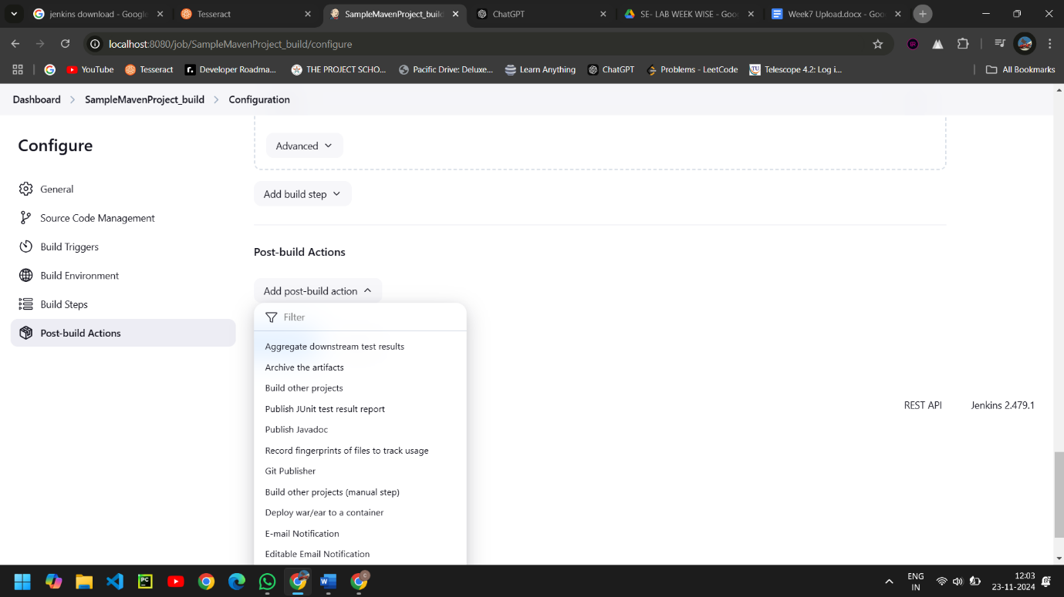

* If we want to archive all the artifacts type **/* as shown.

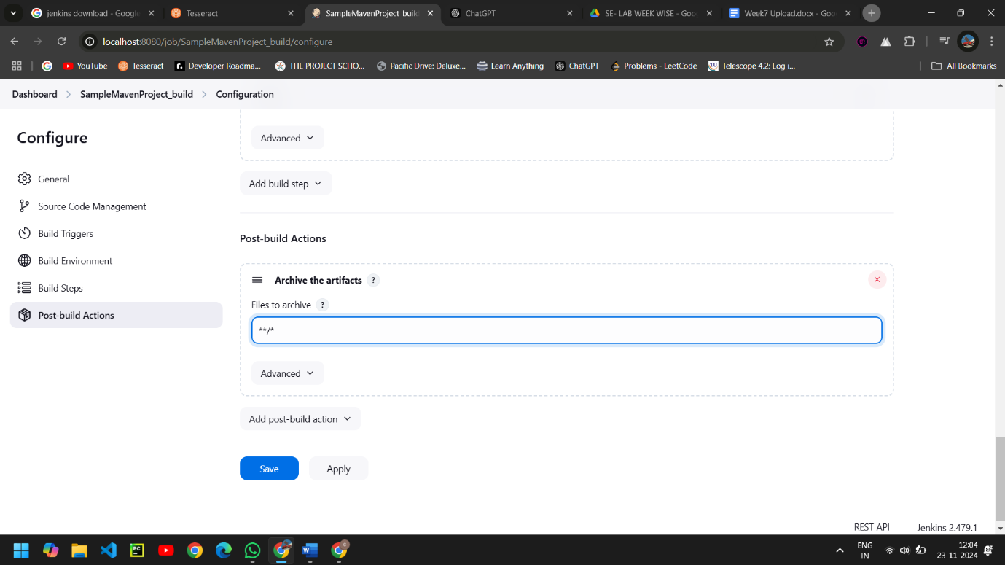

* Now the next step is to build other projects, where we will create a test project which will be triggered by the build project.

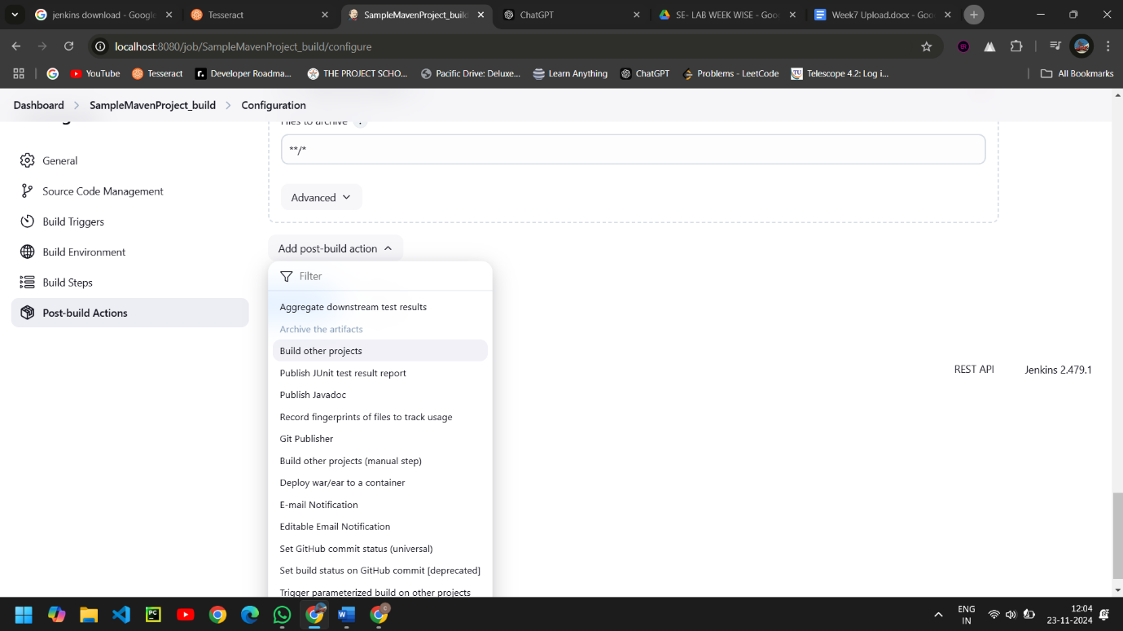

* Ignore the red warning, as we have not yet created the test project, click on Apply and Later Save

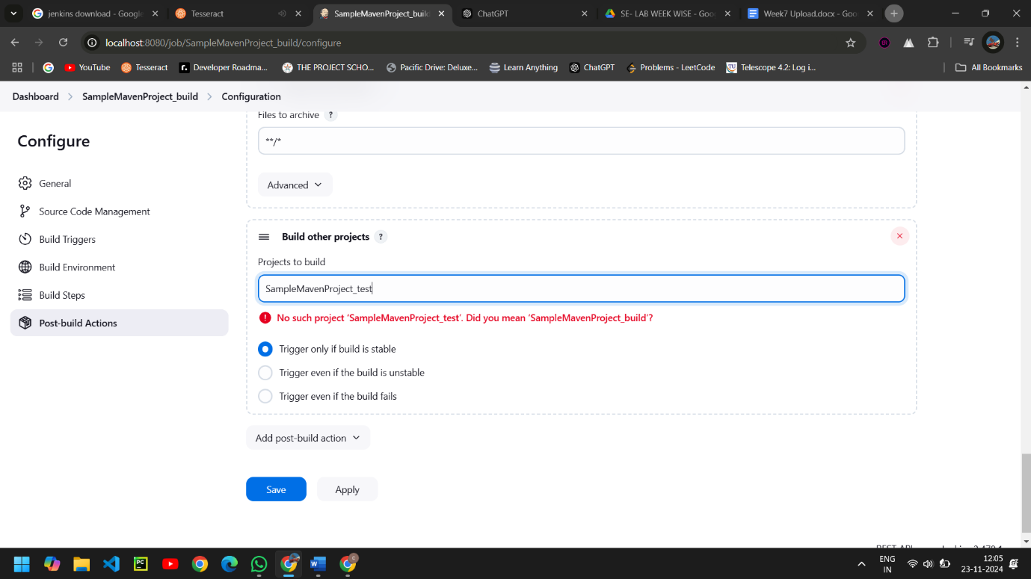

* Create a new freestyle project test as shown and click ok.

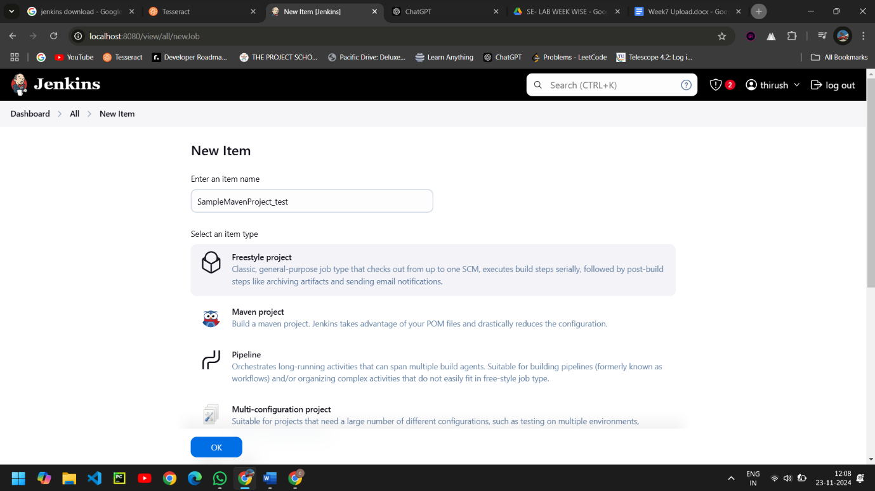

* This time we need not mention the git repository so select None.

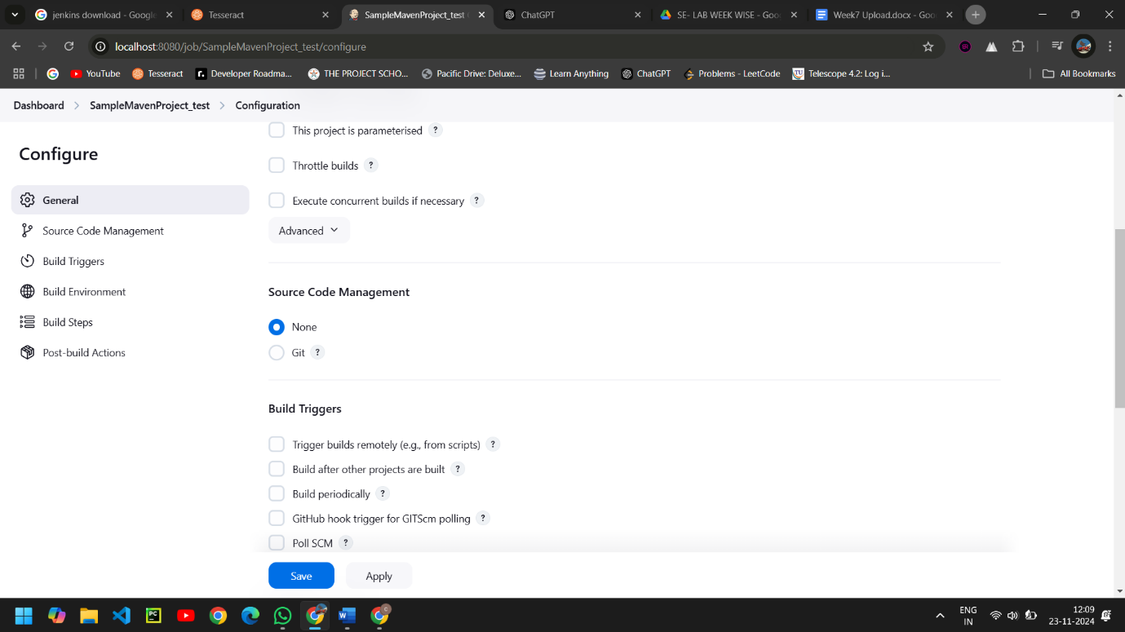

* In Build environment check the box as shown below, this is to discard old builds.

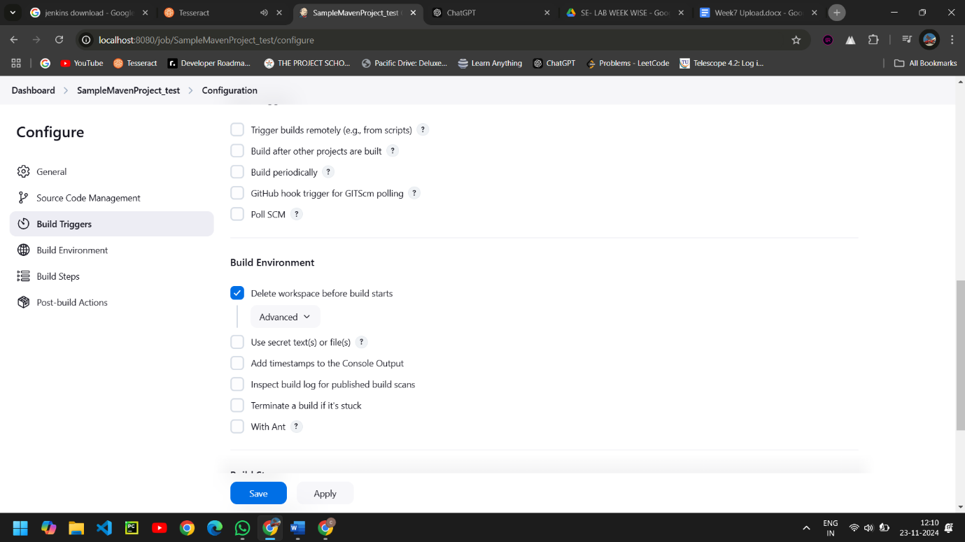

* To forward the artifacts of the previous project to the current test project, select copy the artifacts from another project in Build as shown.

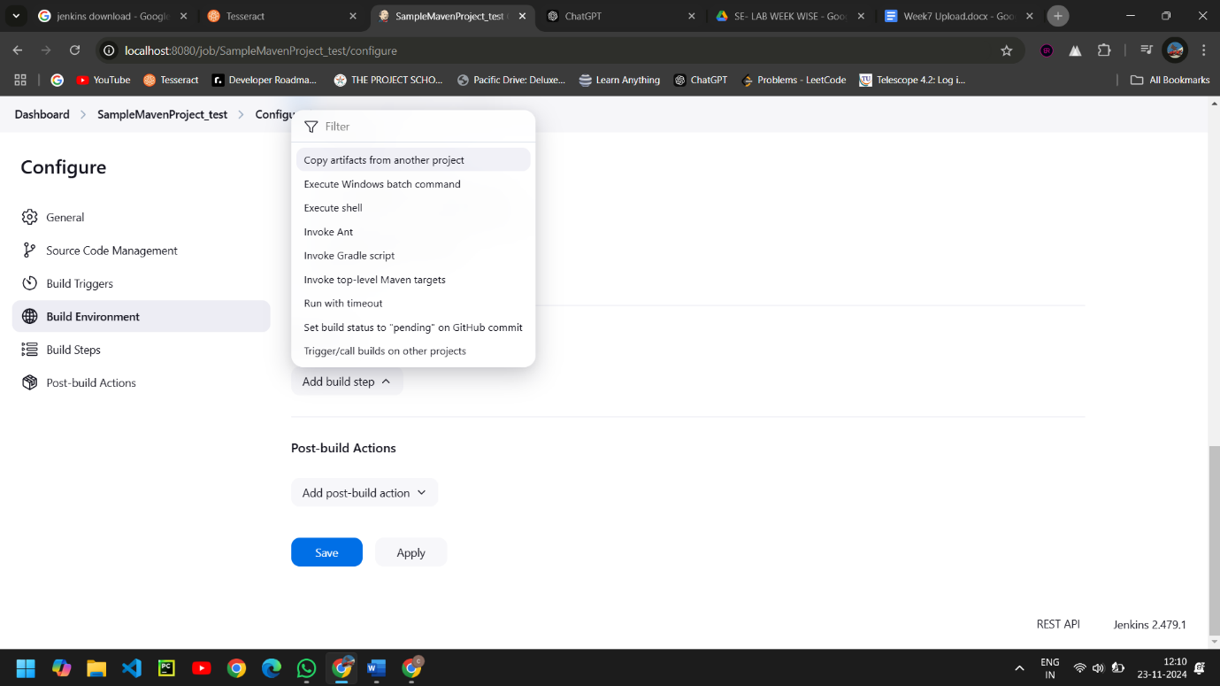

* Give the name of the project from which we want to copy the artifacts and check the box ->stable build only->to copy all the artifacts type **/*.

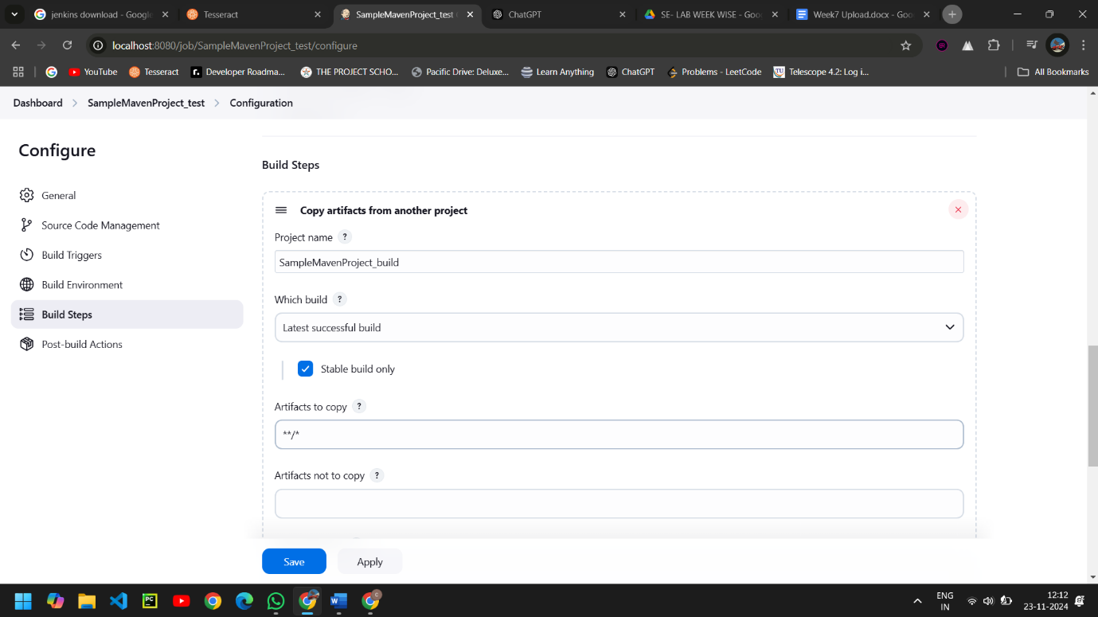

* Now select Invoke top-level Maven targets in build. This time give the goal as test after selecting the Maven version.

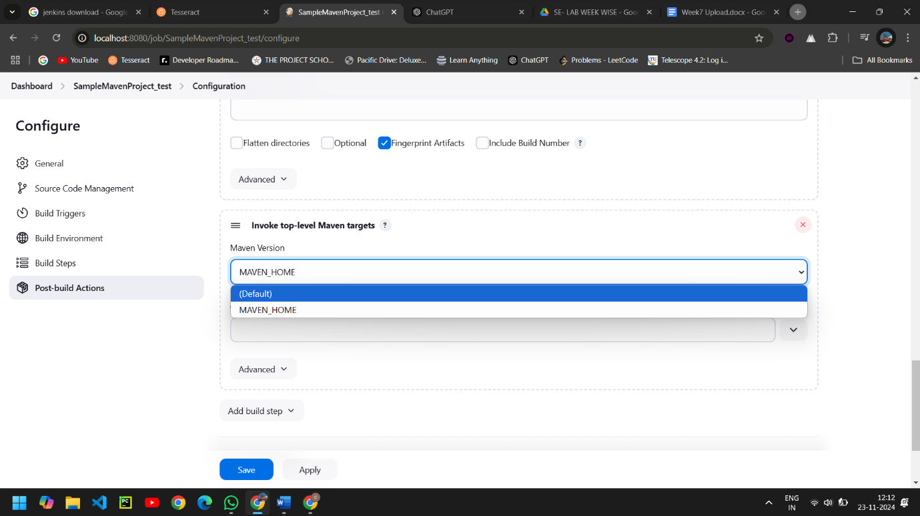

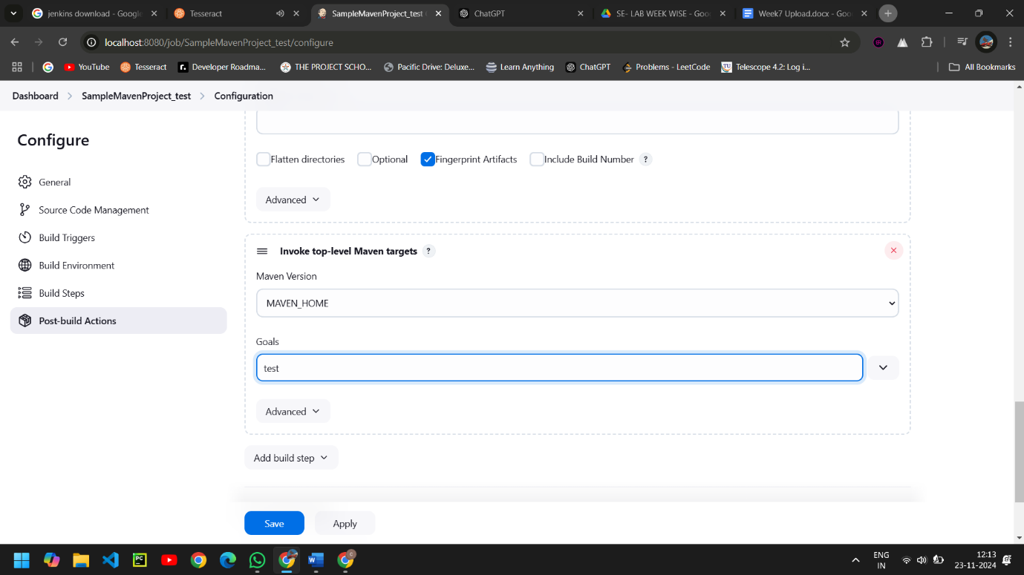

* In post-build actions->select Archive the artifacts.

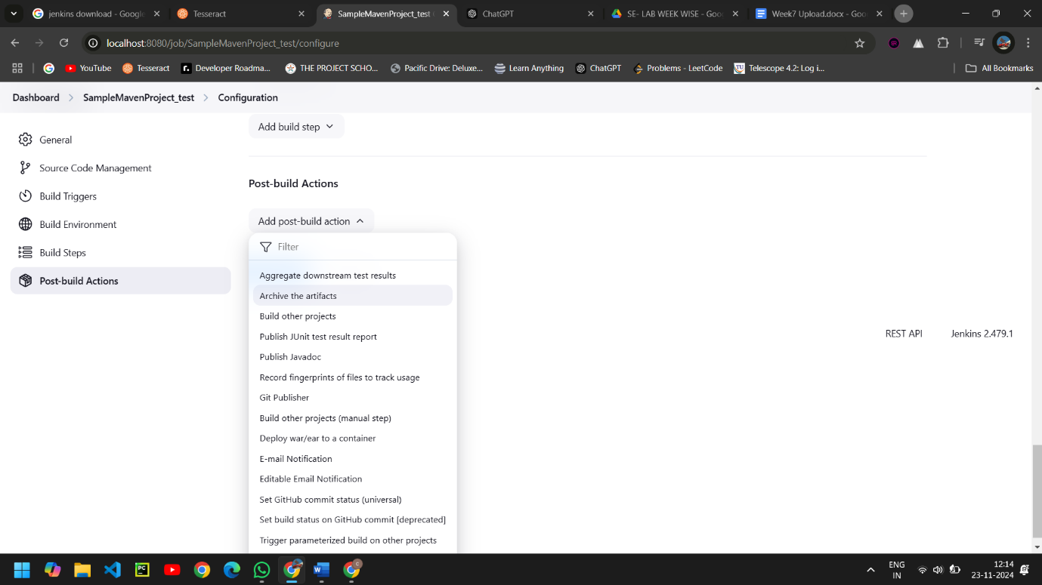

* To save all the artifacts->type **/* and Apply->Save.

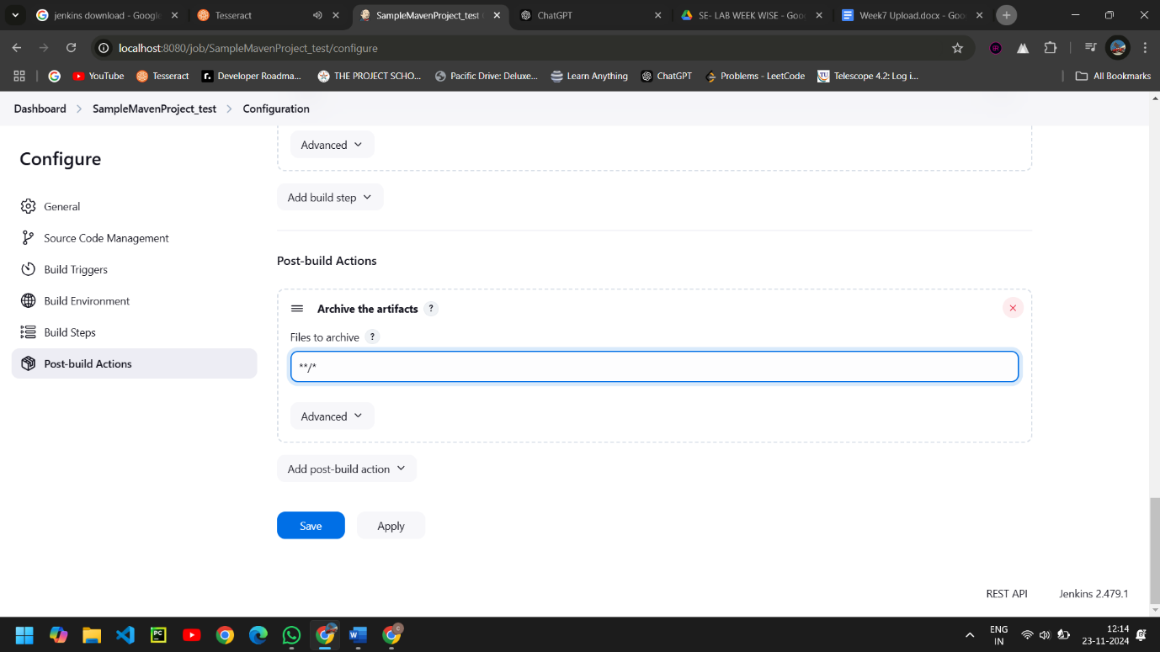

* Create a pipeline by clicking on + symbol in the dashboard ->a pipeline is a collection of events or jobs which are interlinked with one another in a sequence.

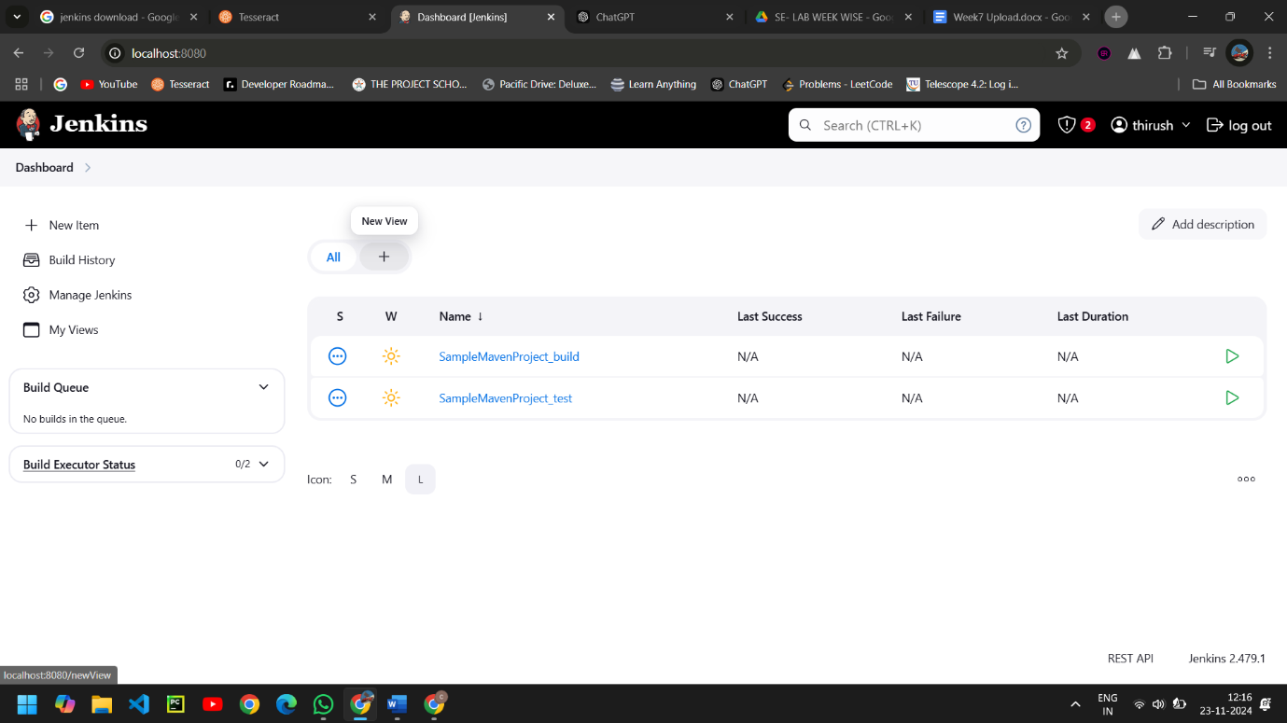

* Give a name to the pipeline->select Build Pipeline View->create.

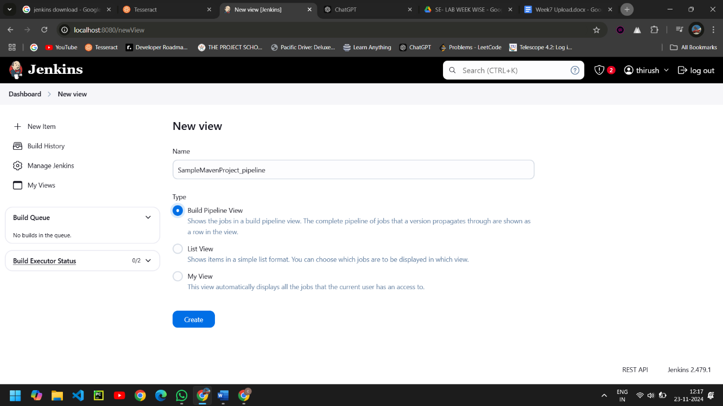

* Select the first project to trigger the execution->build project ->Apply ->Ok.

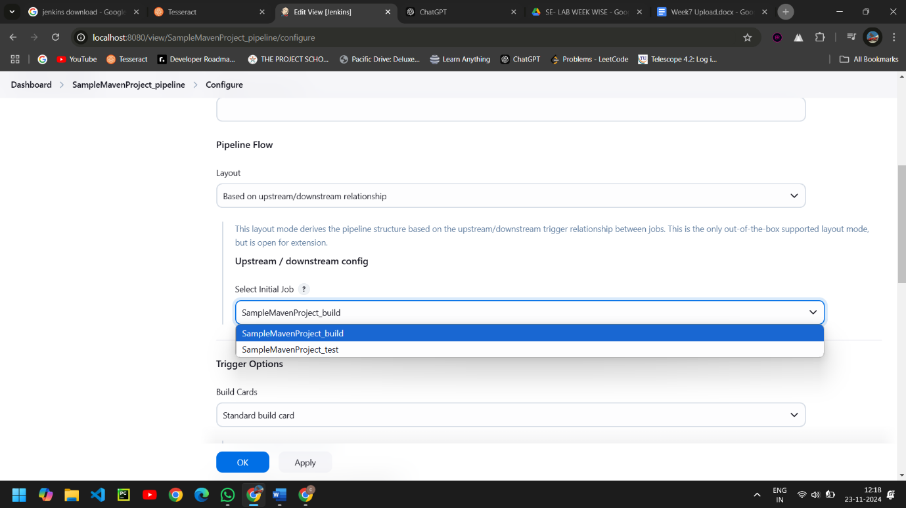

* Click on Run -> click on the small black box to open the console to check if the build is success.

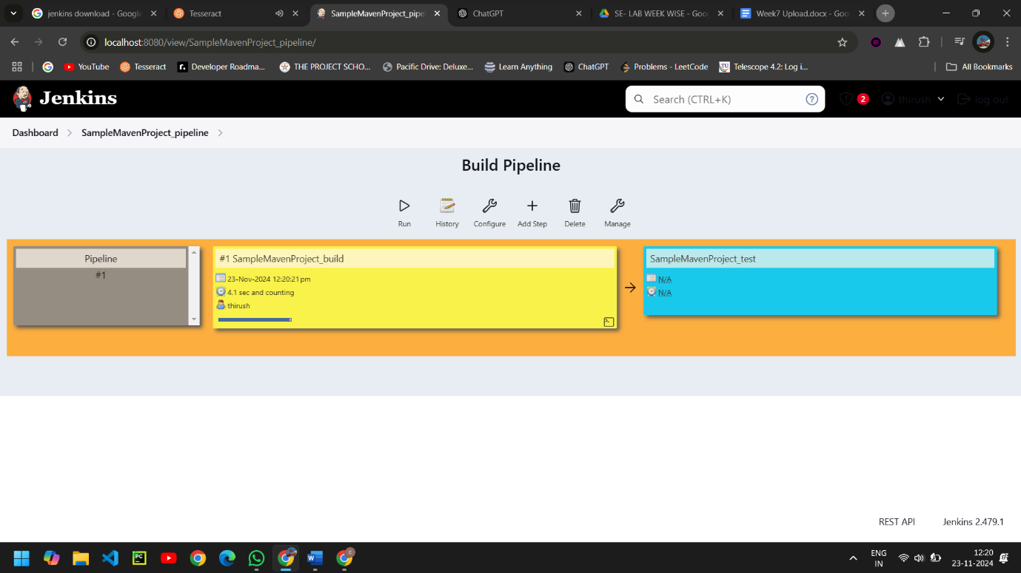

* We can see that the build is success and the test project is also automatically triggered.
* The pipeline is successful if it is in green color as shown ->check the console of the test project.

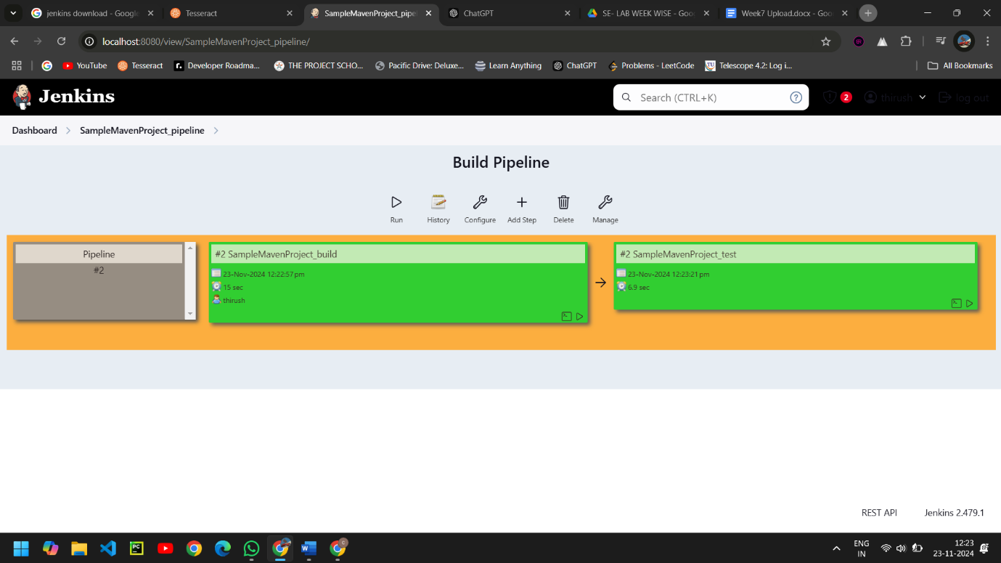

* The test project is successful and all the artifacts are archived successfully.

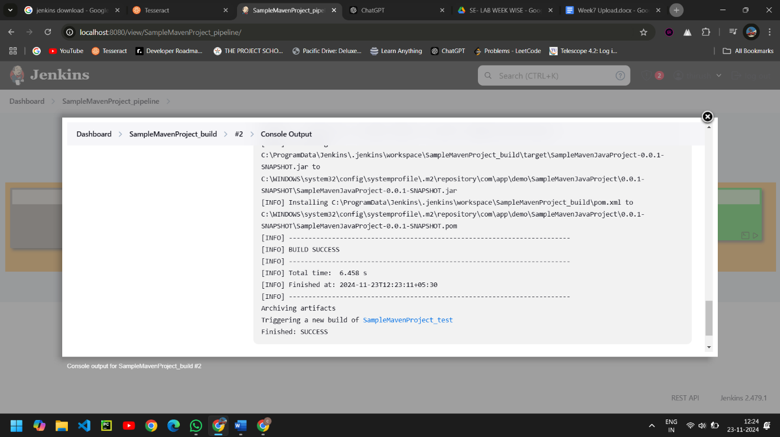

**BUILDING THE FREESTYLE PIPELINE USING JENKINS FOR MAVEN WEB PROJECT**

* Open Jenkins in local host:8080 and create a new item.

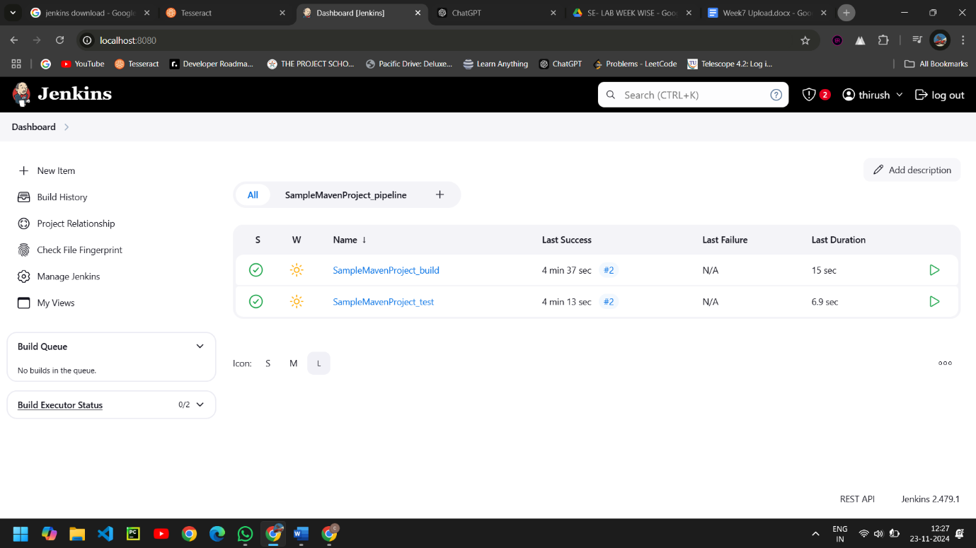

* Name it, and select as -> SampleMavenWebProject_build ,click on-> ok.

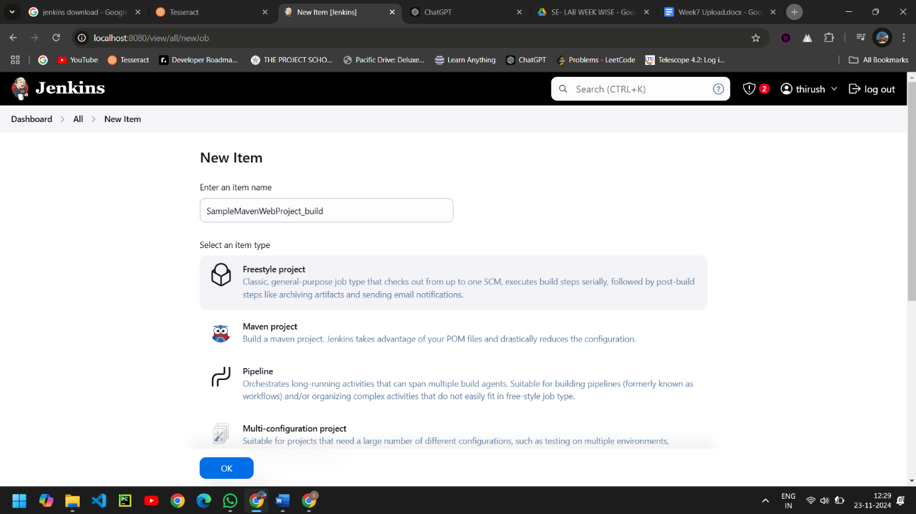

* Paste the URL in Repository URL , Specify the Branch as either Master/Main as it is in the GitHub.

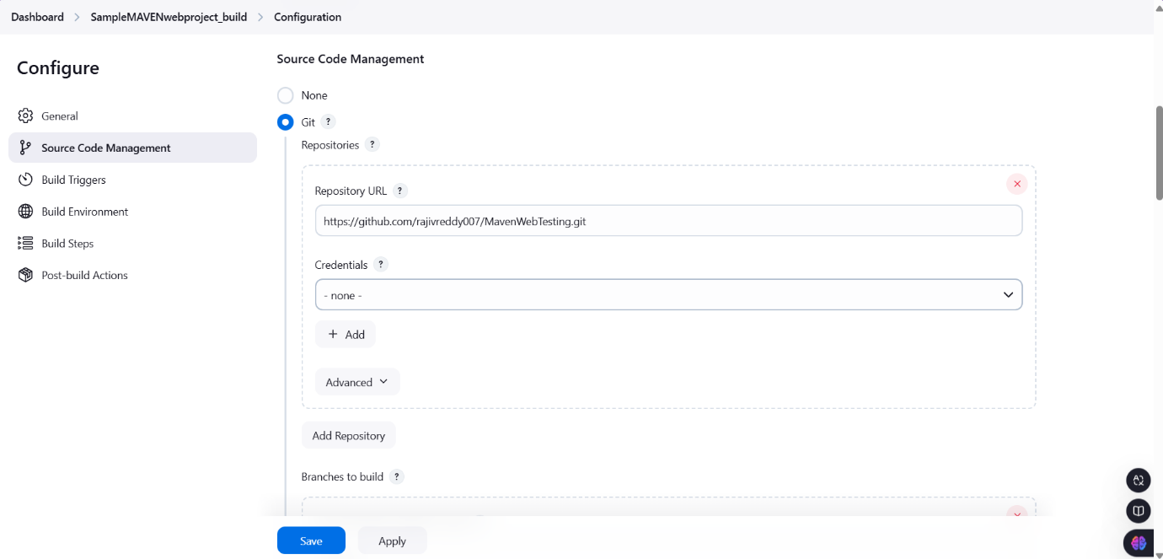

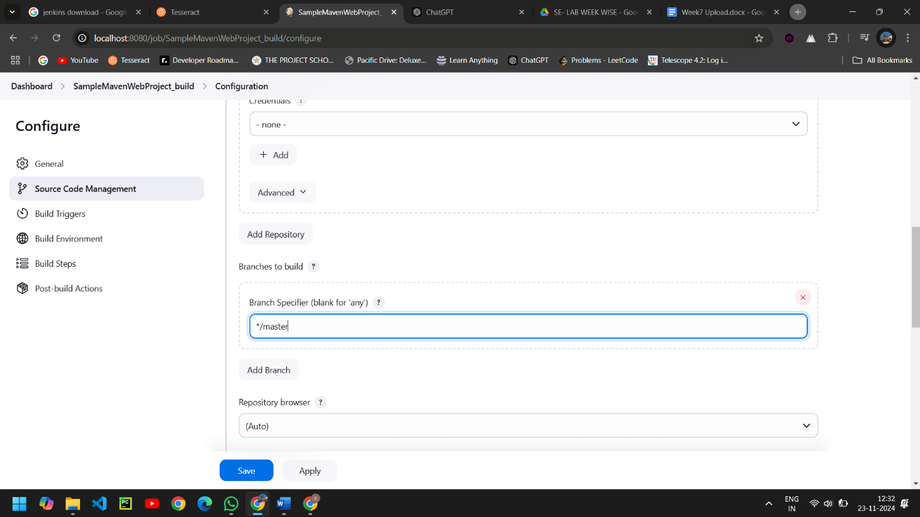

* Select Poll SCM in Build Triggers, and Schedule as shown.

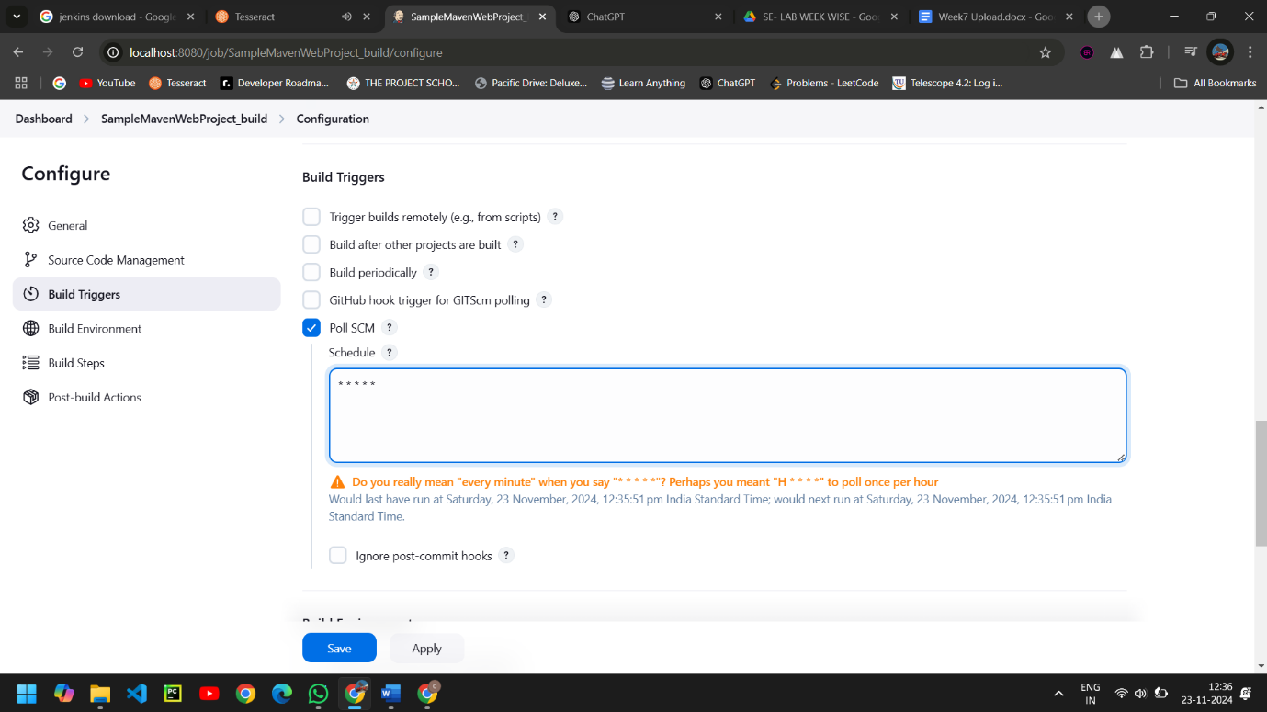

* Now in Build, Select Invoke top-level Maven targets.

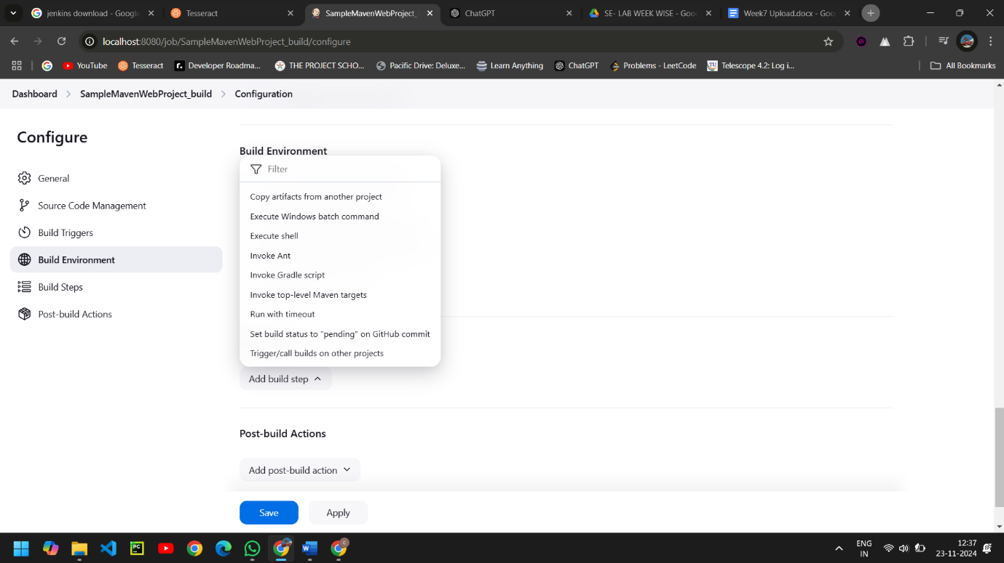

* Select the Maven path which is already set in the global credentials in Manage Jenkins. Now we follow the goals of as starting with clean and install.

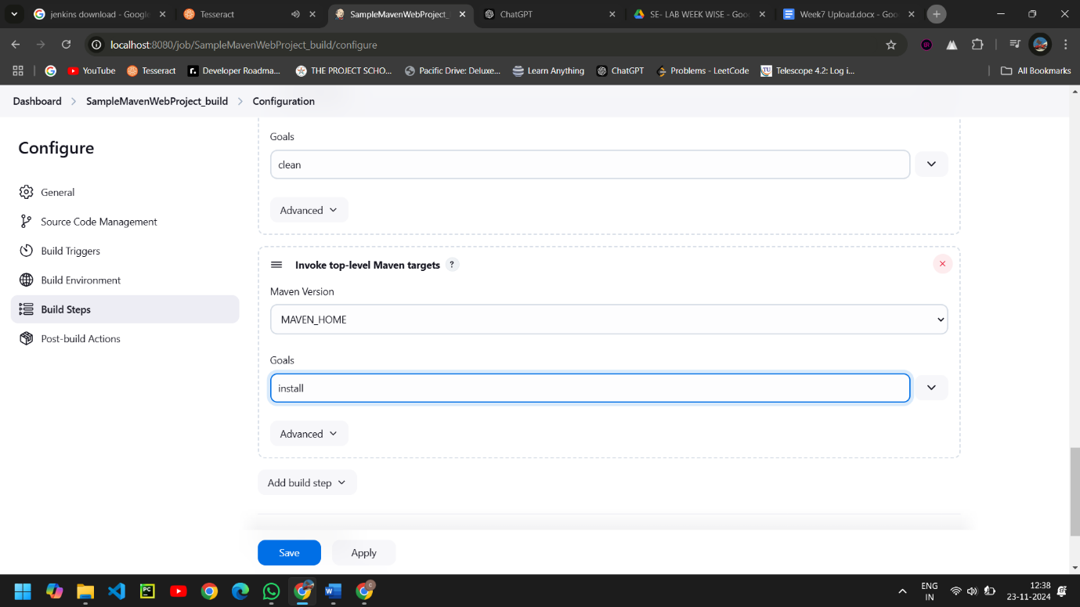

* Now we go for post build select the Archive artifacts -in Jenkins it is a feature that allows us to store the output files after we build the project with Jenkins.

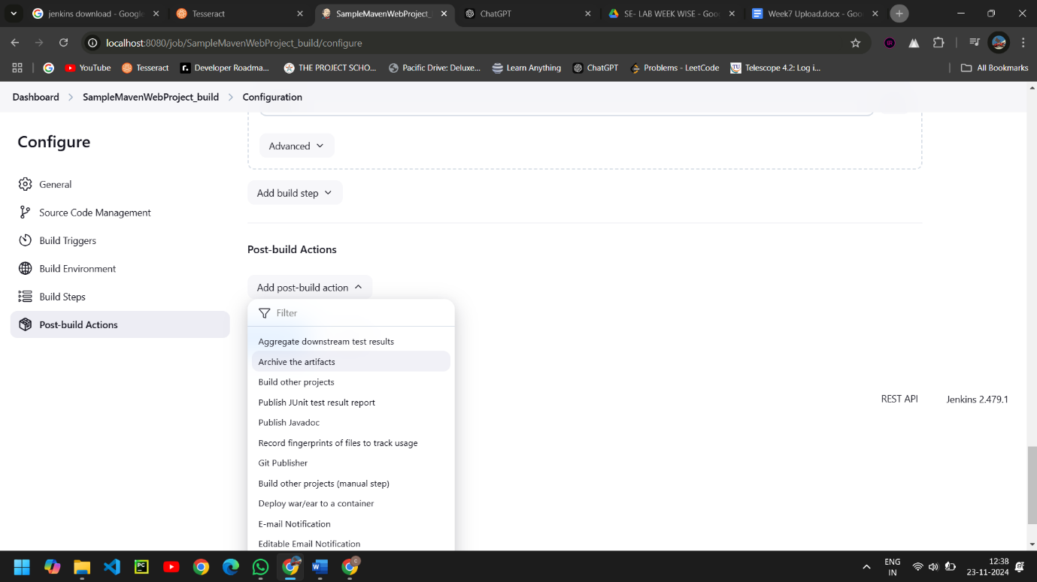

* To archive the artifacts we go for **/*.

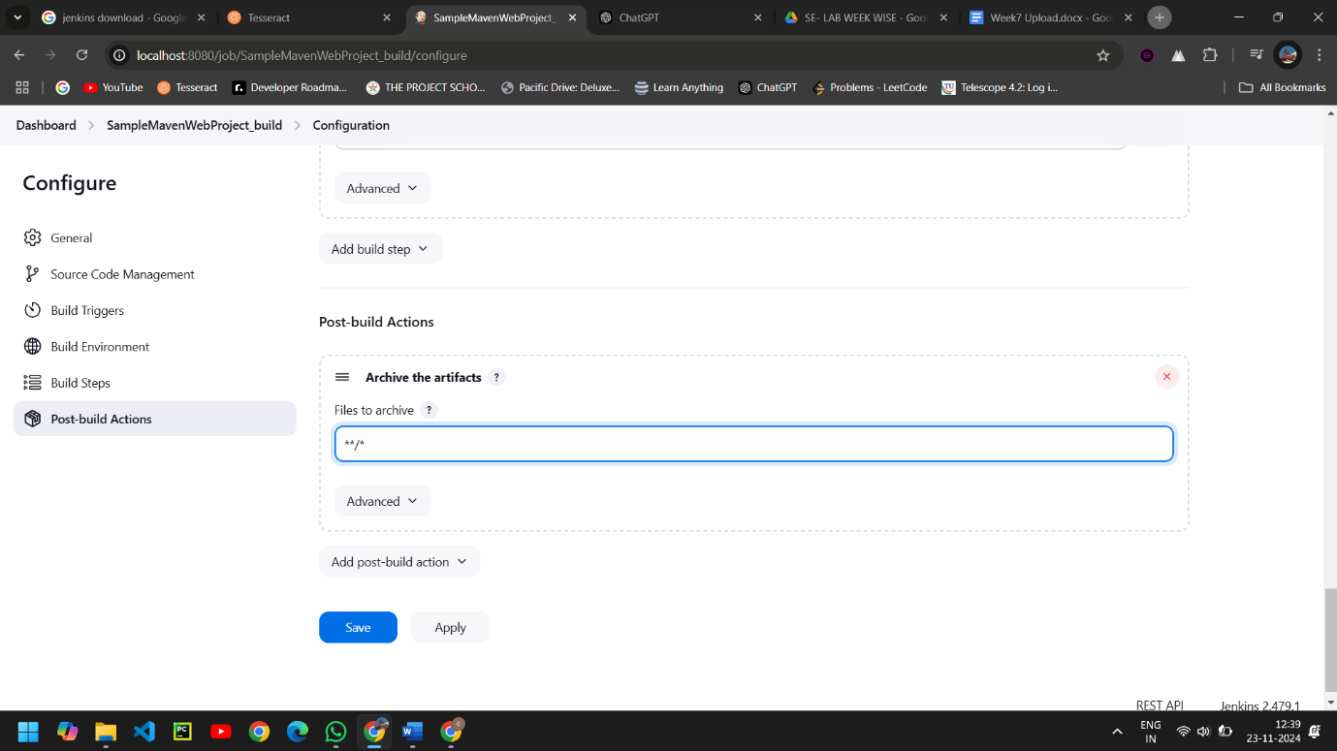

* Now we here select the build other projects, where we will create a test project which will be triggered by the build project, click on Apply and Save.

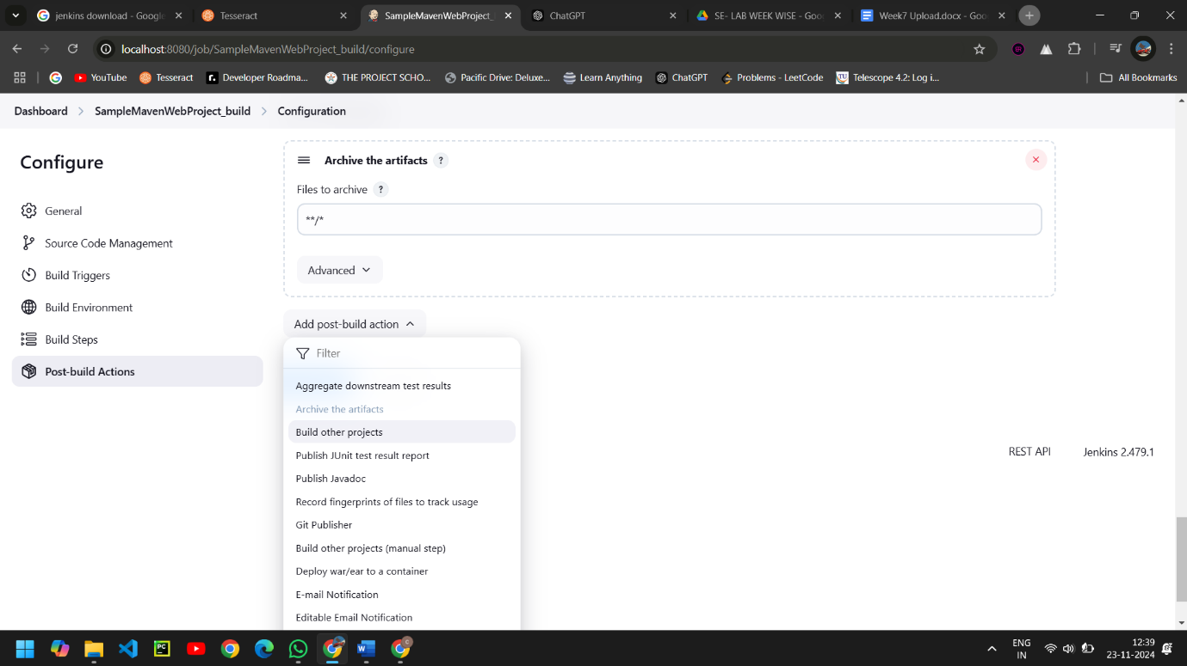

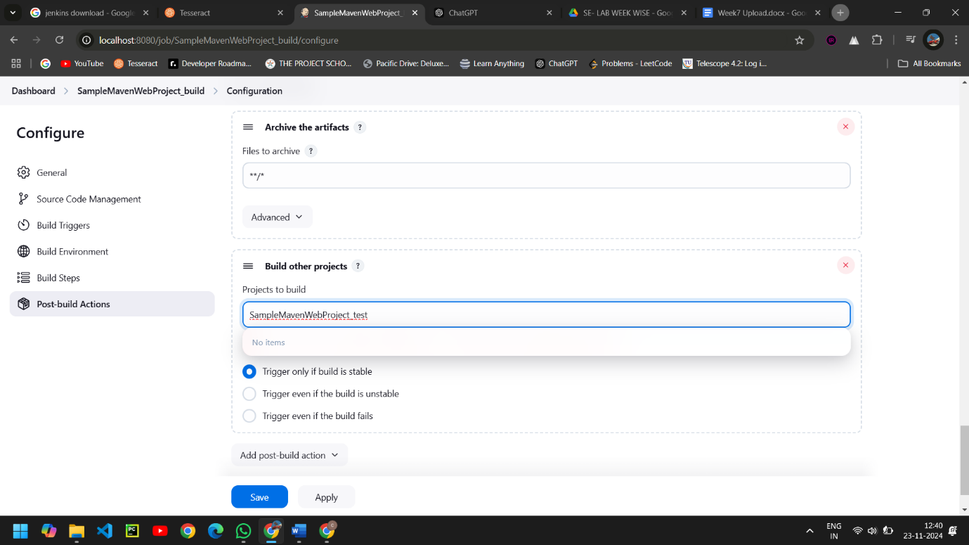

* Create a new freestyle project test as shown and click ok.

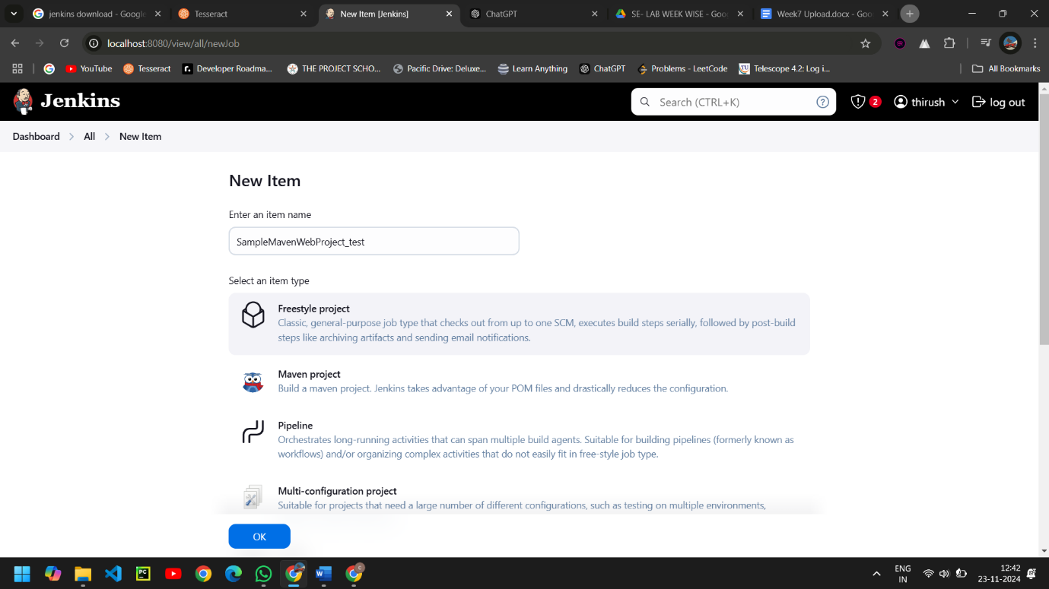

* In Build environment check the box as shown below, this is to discard old builds, To forward the artifacts of the previous project to the current test project, select copy the artifacts from another project in Build as shown.

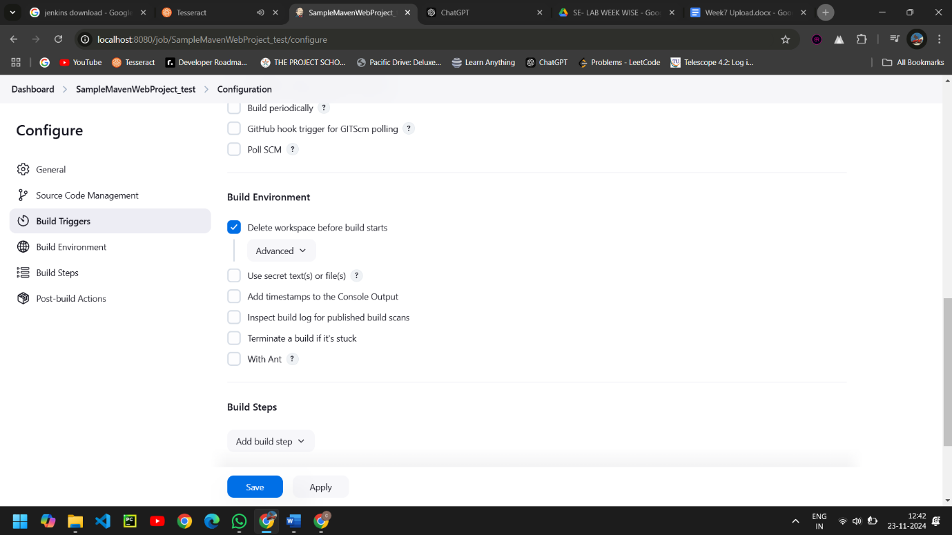

* Give the name of the project from which we want to copy the artifacts and check the box ->stable build only->to copy all the artifacts type **/*.

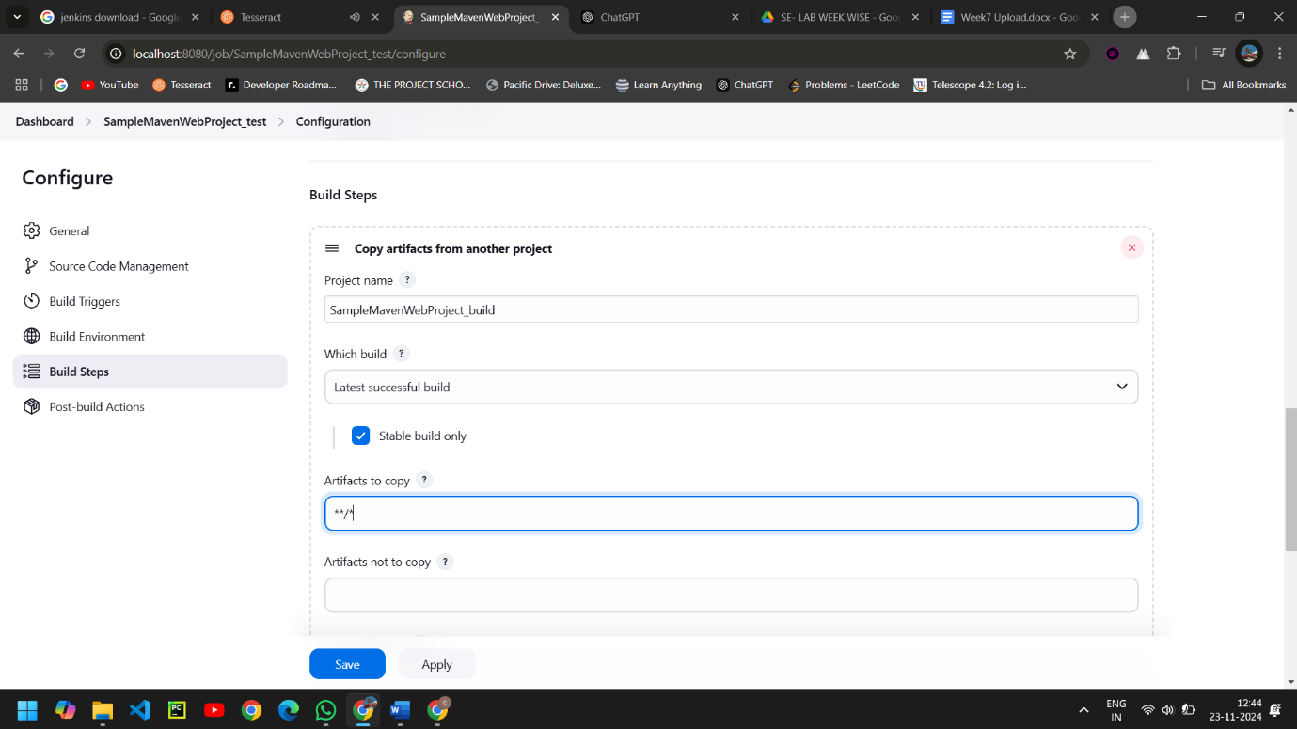

* Now in Build, Invoke top-level Maven targets, choose the Maven Path and select goal as test .

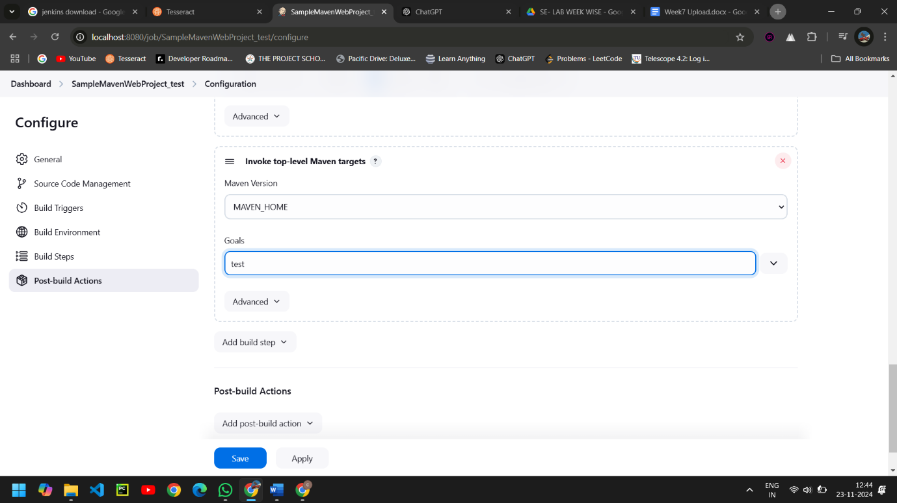

* To archive the artifacts we go for **/*..

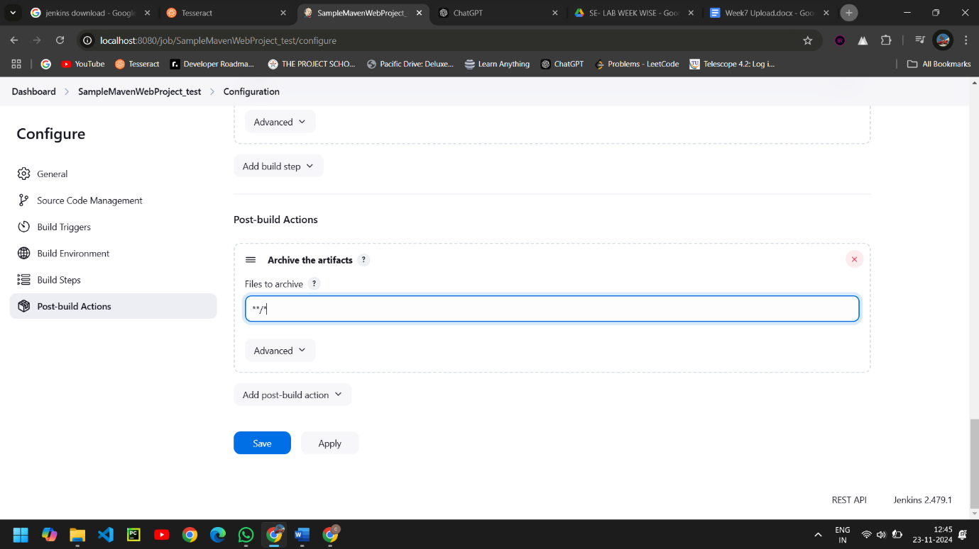

* Now we here select the build other projects, where we will create a deploy project which will be triggered by the test project, click Apply and Save.

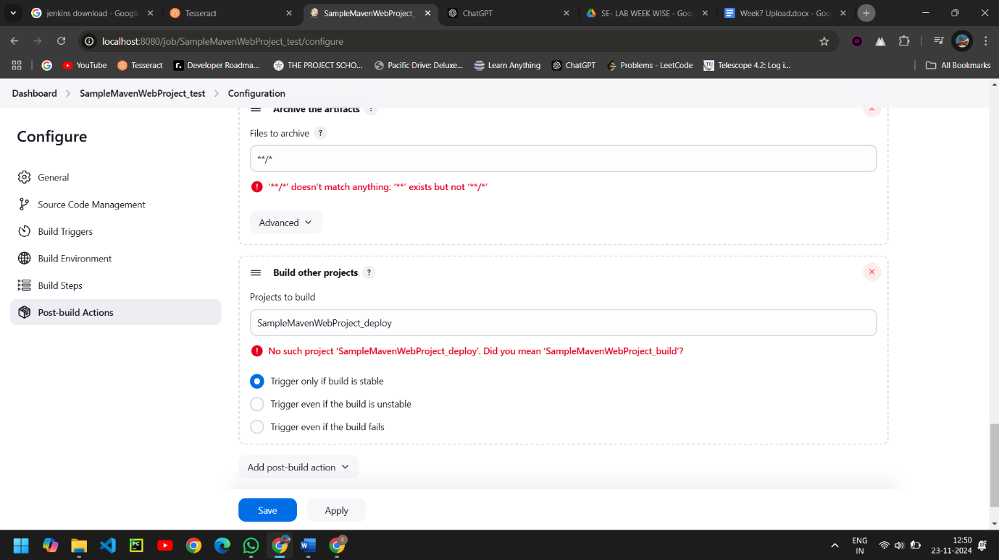

* Create a new freestyle project deploy as shown and click ok.

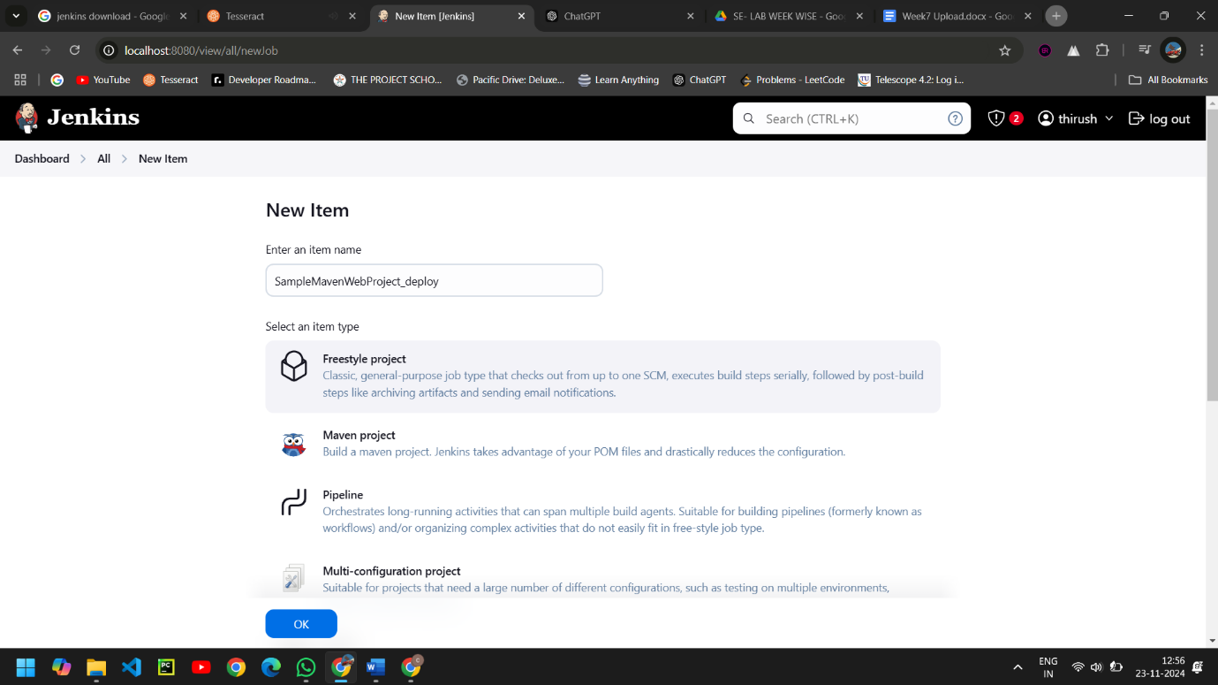

* In Build environment check the box as shown below, this is to discard old builds.

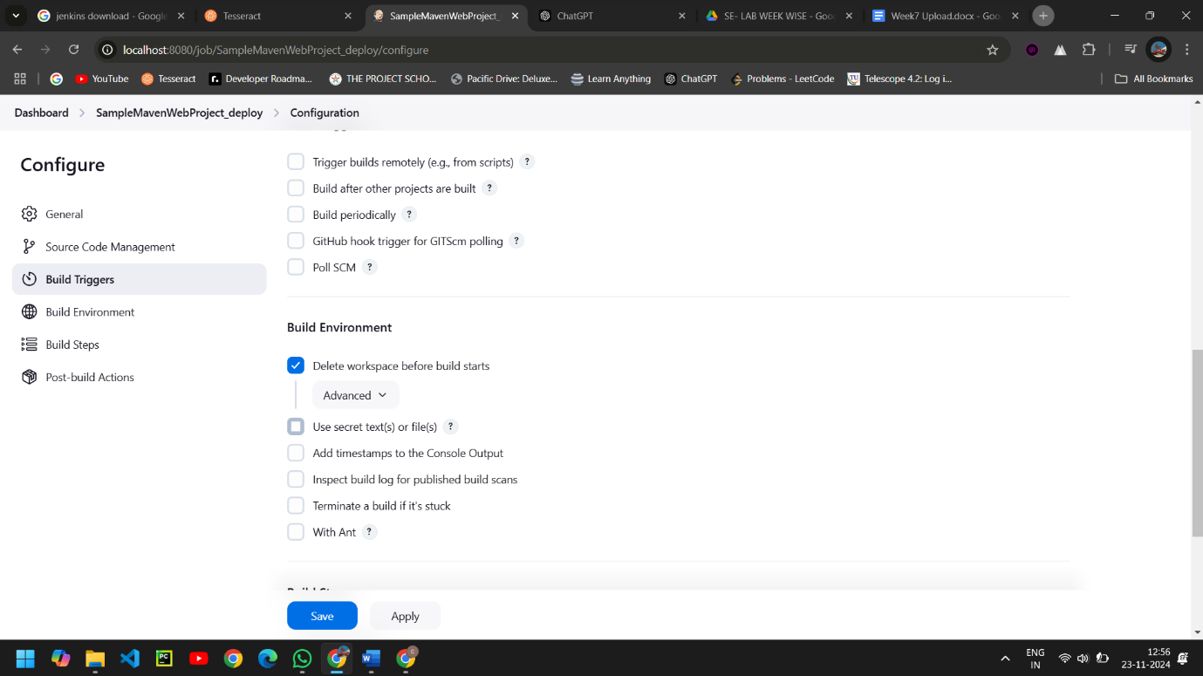

* Give the name of the project from which we want to copy the artifacts and check the box ->stable build only->to copy all the artifacts type **/*.

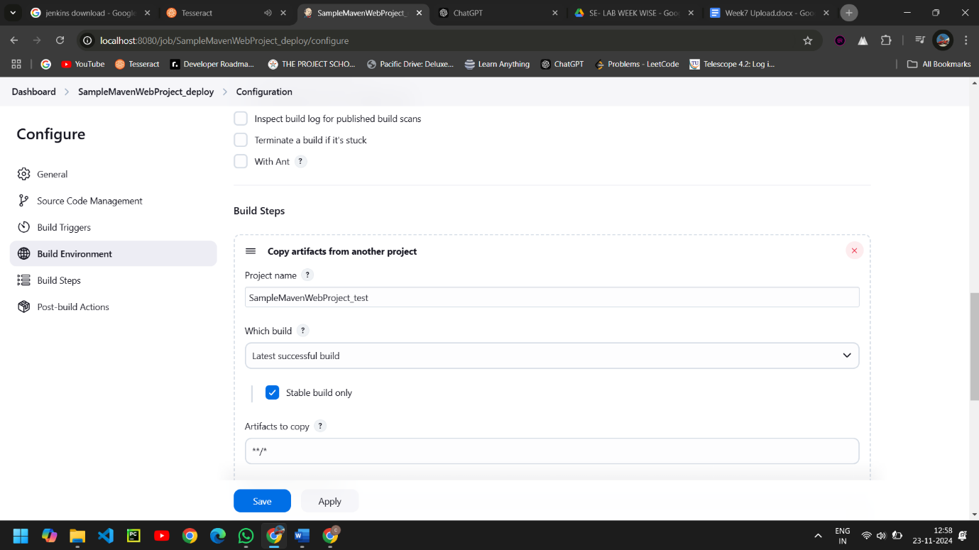

* Now here we go for Add post –build action, where we select the Deploy war/ear to a container.  
  This **plugin** takes a **war**/**ear** file and deploys that to a running remote application server at the end of a build.

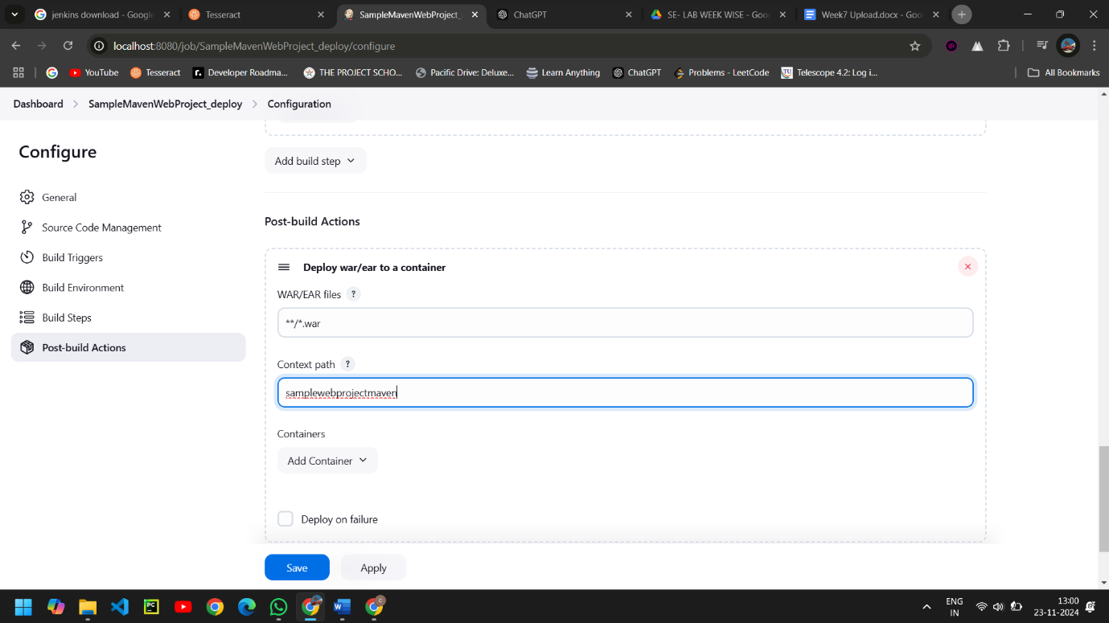

* Here we select the tomcat version .

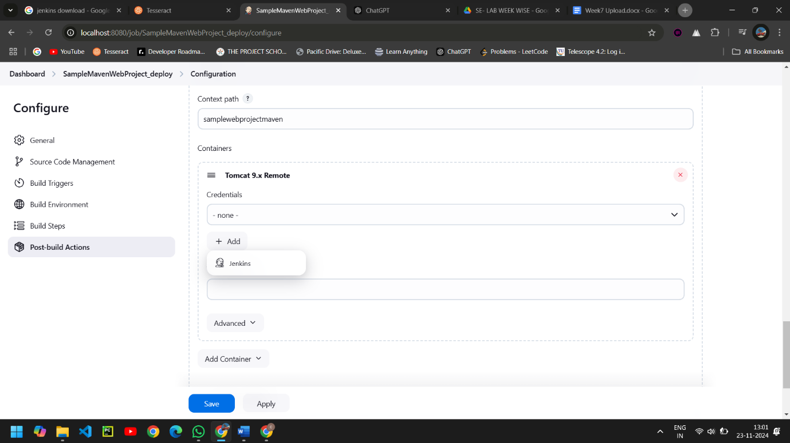

* Here we add the credentials of tomcat.

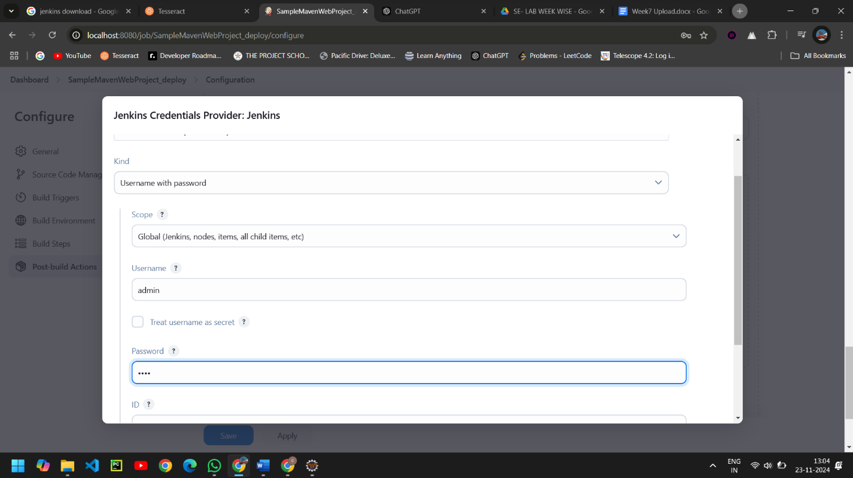

* Here we select the credentials of tomcat and add tomcat URL. Then click Apply and Save.

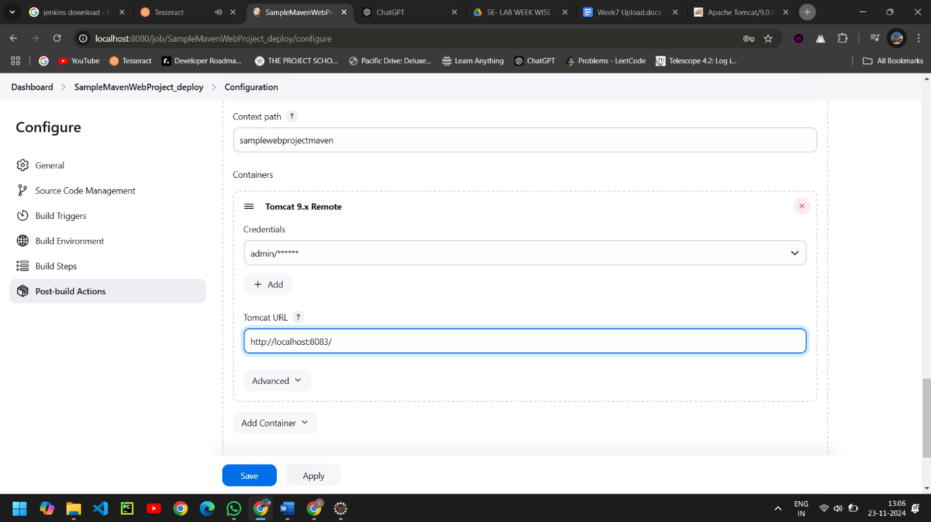

* We Create a pipeline by clicking on + symbol in the dashboard ->a pipeline is a collection of events or jobs which are interlinked with one another in a sequence.

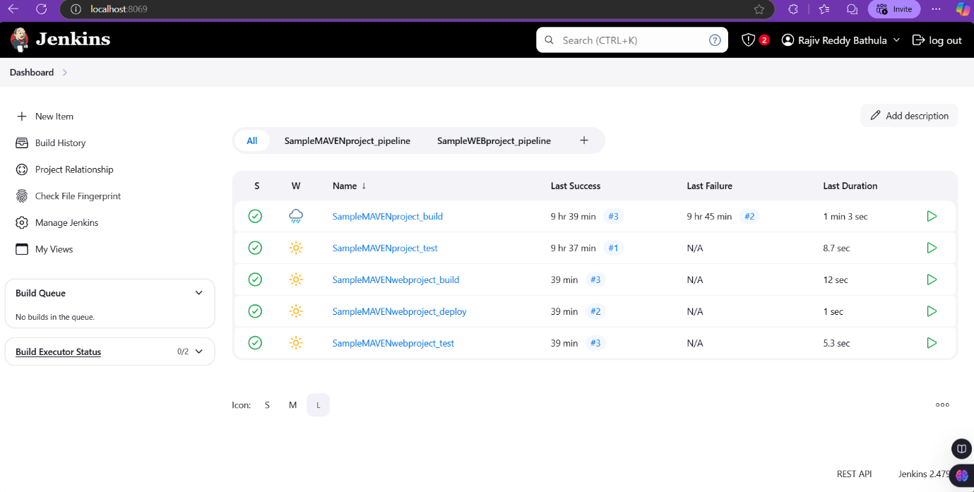

* Give a name to the pipeline->select Build Pipeline View->create.

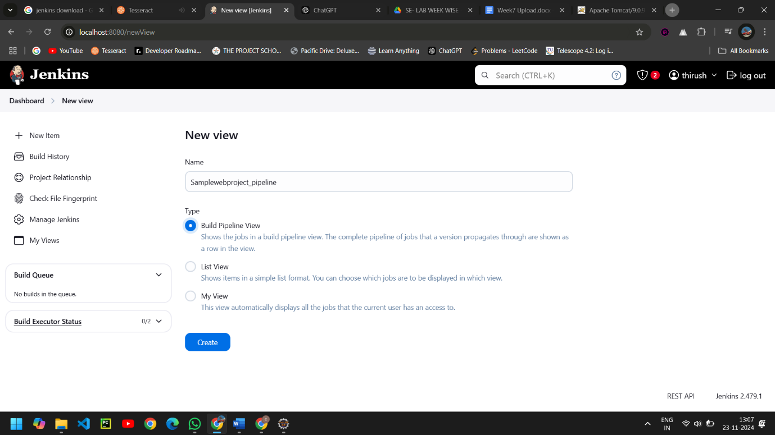

* Select the first project to trigger the execution->build session of your project. Then click Apply and Ok.

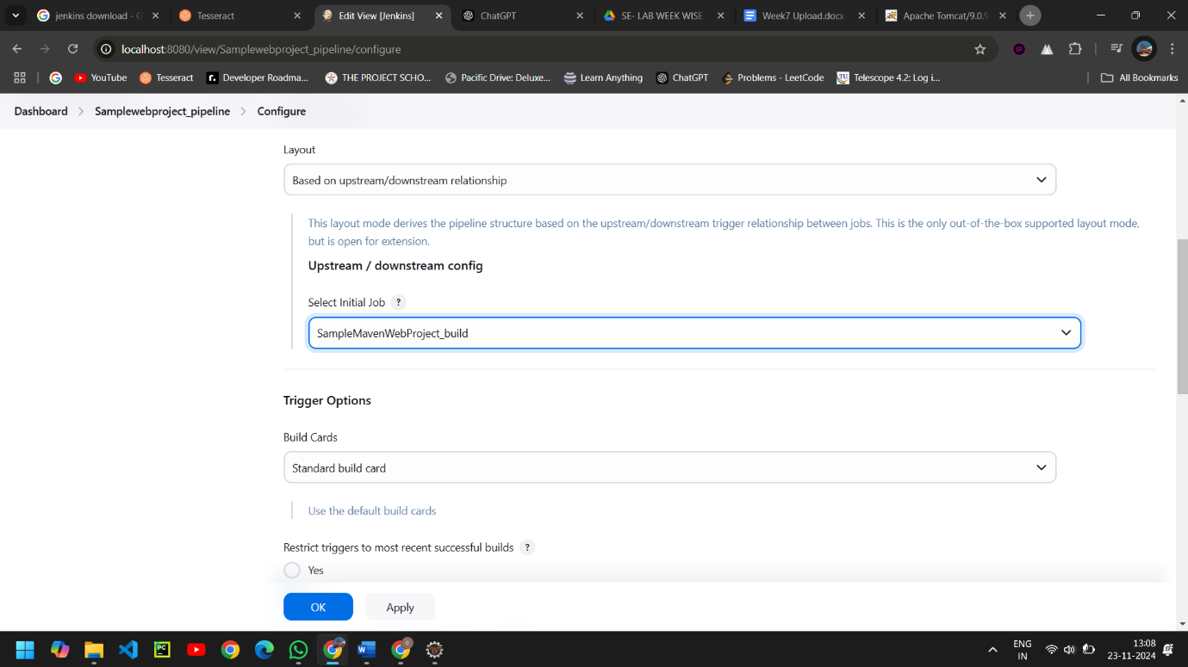

* Click on Run -> click on the small black box to open the console to check if the build is success.

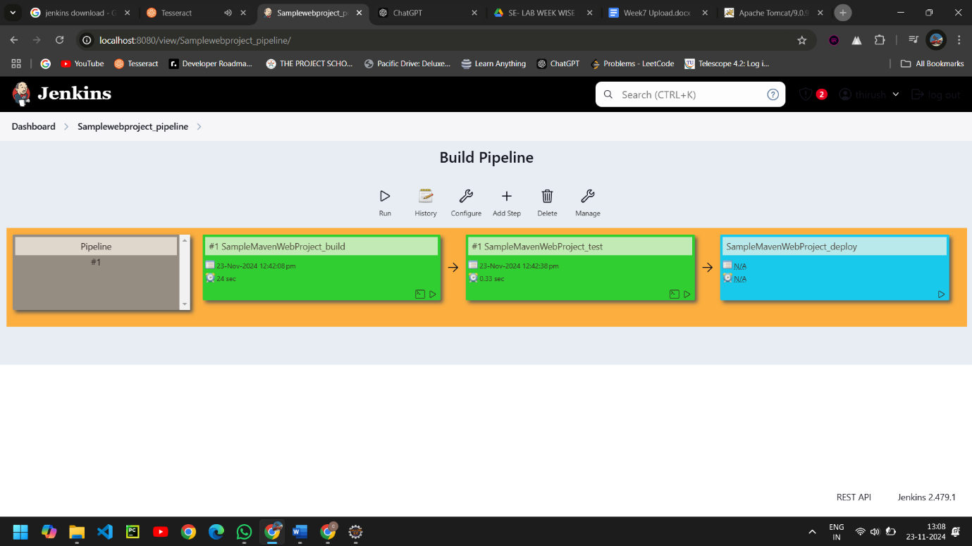

* Now we see all the build has success.

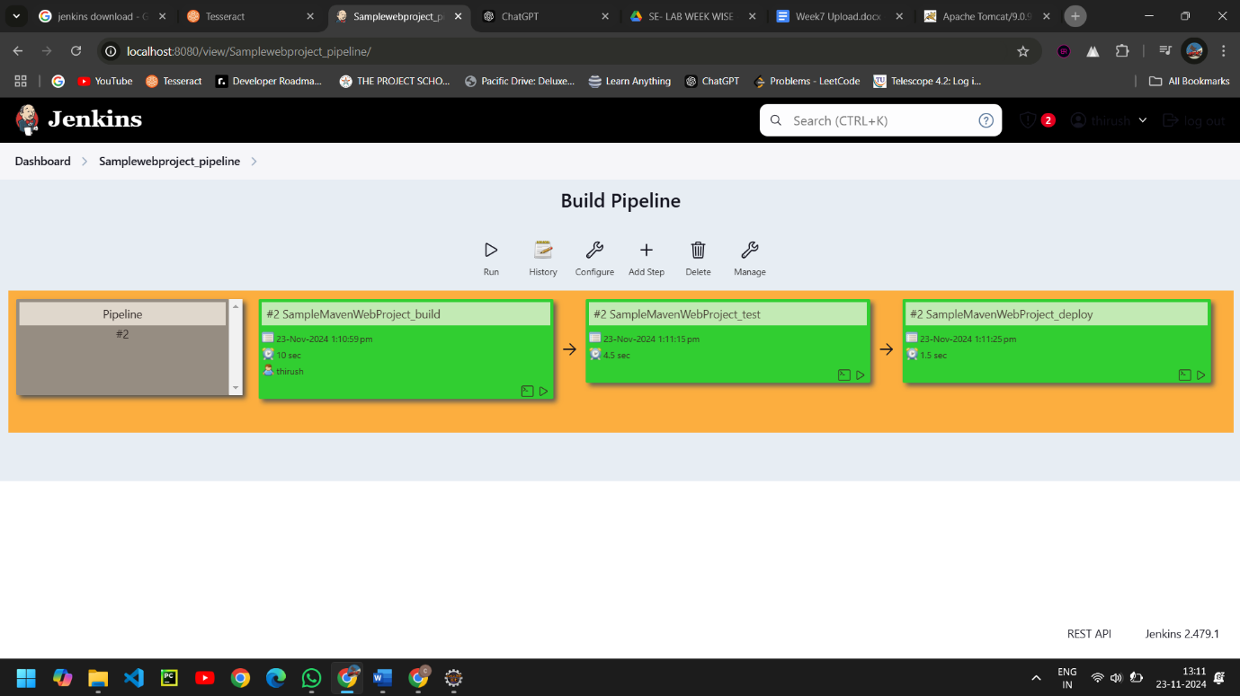

* Now run the local host of tomcat, click -> manager App. It ask for user credentials for login , provide the credentials of tomcat.

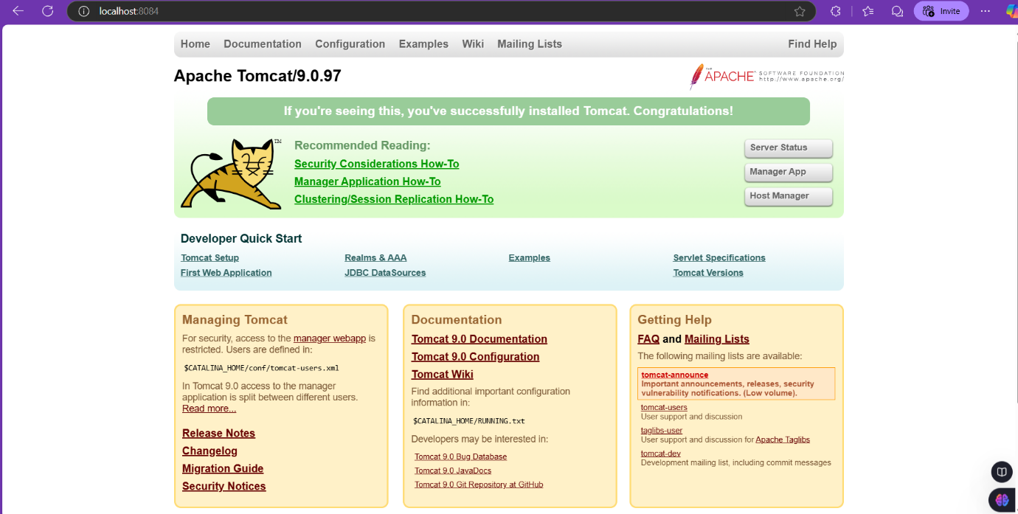

* It provide the page with out project name which is highlighten.

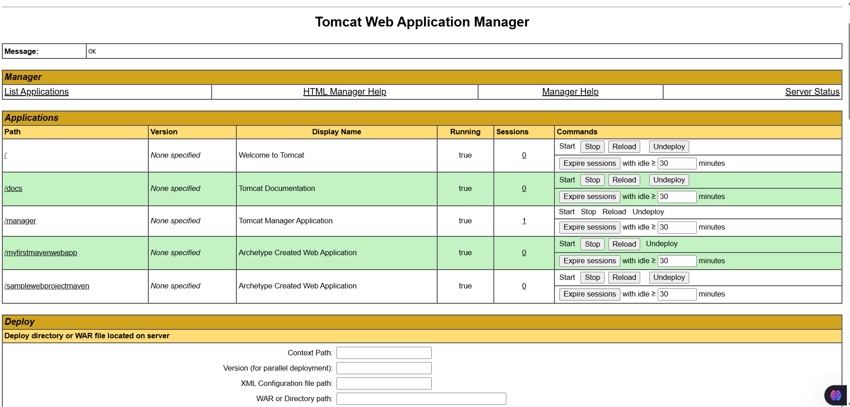

* After clicking on our project we can see our output here .

